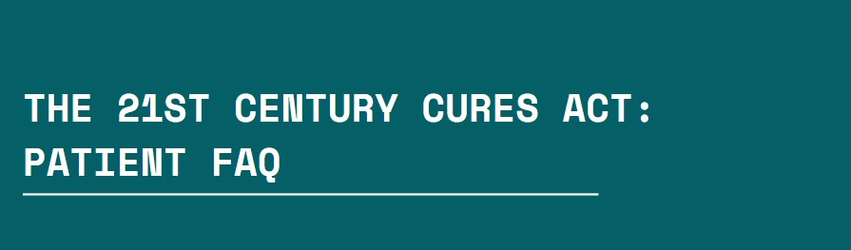

# What is the 21st Century Cures Act?

In 2020, the Office of the National Coordinator for Health IT (ONC) released the Cures Act final rule regulating: (1) the certification criteria under the voluntary program for certification of Health IT modules, (2) the conduct of developers participating in the certification program, and

## (3) the electronic sharing of health information (i.e., information blocking regulations).

**When did it go into effect?**

The information blocking section of the rule that regulates the sharing of electronic health information (EHI) was applicable to health care providers **beginning April 5, 2021**.

# What is “information blocking?”

Information blocking refers to practices that intentionally prevent or hinder the access, exchange, or use of electronic health information. This can occur when healthcare providers, health IT developers, or other entities, such as health systems, engage in actions that make it difficult for patients, healthcare providers, or others to access and share medical records or health information. These actions can include refusing to release medical records to patients, charging excessive fees to access medical records, implementing systems or practices that make it difficult to share records, and data blocking.

# What rights do I, as a patient, have to my medical records?

Patients have certain rights when it comes to their medical records, and these rights are protected by laws like the Health Insurance Portability and Accountability Act (HIPAA) in the United States.

**Access to Records:** Patients have the right to request and receive copies of their medical records. Healthcare providers are generally required to provide access within a reasonable timeframe.

**Requesting Corrections:** If patients believe there are inaccuracies in their medical records, they have the right to request corrections or amendments.

**Privacy and Security:** Patients' medical records must be kept private and secure. Healthcare providers and entities must take measures to protect the confidentiality of health information.

**Sharing with Others:** Patients can authorize the sharing of their medical records with other healthcare providers, family members, or individuals they designate.

**Refusal of Access:** In certain circumstances, healthcare providers can refuse access to medical records, but they must provide a reason for the denial. Patients can appeal such decisions.

**Obtaining Records at a Reasonable Cost:** Patients may be charged a reasonable fee for copies of their medical records, but this fee should not be excessive.

**Electronic Access:** Patients have the right to request electronic copies of their health records if they are available in electronic format.

## These rights are designed to empower patients and ensure they have control over their health information while also promoting transparency and interoperability in the healthcare system. If you encounter information blocking or difficulties accessing your medical records, you can file a complaint with the Office of the National Coordinator (ONC).