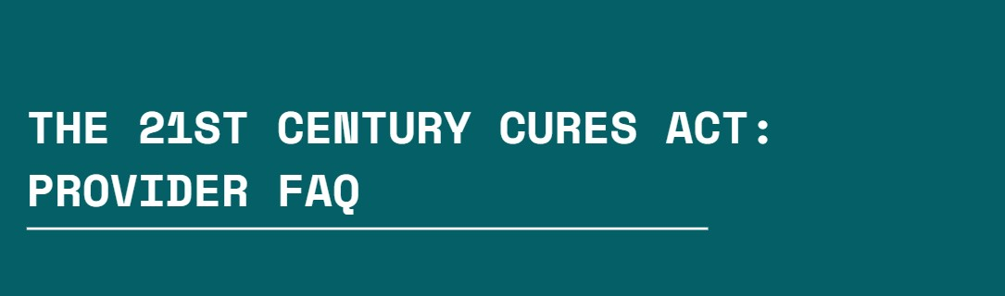

# What is the 21st Century Cures Act?

In 2020, the Office of the National Coordinator for Health IT (ONC) released the Cures Act final rule regulating: (1) the certification criteria under the voluntary program for certification of Health IT modules, (2) the conduct of developers participating in the certification program, and

**(3) the electronic sharing of health information (i.e., information blocking regulations).**

# When did it go into effect?

The information blocking section of the rule that regulates the sharing of electronic health information (EHI) was applicable to healthcare providers **beginning April 5, 2021**.

# Who does it affect?

This includes all healthcare entities and individual provider types and specialties as defined in the Public Services Act (42 U.S.C. 300jj) (i.e., hospital, clinic, FQHC, pharmacy, lab, MD, DO, RN, PA, APNP, pharmacist, dentist, therapist, social worker, etc.).

# Are there any exceptions to the rule?

The exceptions to fulfilling requests for access, exchange, or use of EHI provided in the Cures Act rule align with or are in addition to the HIPAA privacy and security rule requirements for the protection of, release of, and right of access to protected health information.

# Are there fees or penalties for a health care organization or provider who is

**found to be “information blocking?”**

Yes, the HHS OIG will start investigating claims of information blocking beginning **September 1, 2023**. Individual providers will not be subject to OIG civil monetary penalties, but HHS will be issuing a proposed rule for public comment before the end of 2023 to establish appropriate disincentives for providers determined to be information blocking. The OIG will evaluate information blocking claims towards a healthcare organization on a case-by-case basis and consider the individual facts and circumstances for the level of impact, intent, and knowledge.

# What type of health information is required to be shared with patients through

**the Cures Act?**

The Information Blocking section of the rule applies to any patient’s health records maintained electronically by or for your organization. This includes medical and billing records and other records used in whole or in part to make decisions about individuals to the extent the records would be included in your organization’s Designated Record Set (DRS) as defined in HIPAA, regardless of whether your organization meets the definition of a covered entity or whether the electronic data is maintained using certified health technology.

# Are there any exceptions when it comes to sharing certain types of health

**information?**

Yes. The following health information is excluded from the definition of EHI in the IB provisions: psychotherapy notes as defined in HIPAA, information compiled for a civil, criminal, or administrative action/proceeding, and electronic protected health information deidentified consistent with HIPAA.

# How do I know if I may be information blocking?

You may be information blocking if you or your organization operationalizes any policies, processes, procedures, or workflows (i.e., practices) that you or your organization know (i.e., have requisite knowledge) are unreasonable and likely to interfere with the legally permissible access, exchange, or use of EHI and cannot meet the conditions of an allowable IB exception.