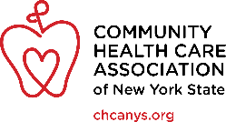

Social Media Messaging Template
***Internal Use Only, Do Not Distribute***
HASHTAGS
- #ValueCHCs
- 340B Hashtags: #Save340B #340BCarveOut
TWITTER (280 character limit)
General Messaging
- CHCs are NY’s safety net and access point for healthcare services! @GovernorHochul @YourLegislator Support CHCs in the NYSBudget! #ValueCHCs
- Ensure New Yorkers have access to affordable and quality healthcare by supporting CHCs in the NYS budget! #ValueCHCs @GovernorHochul @YourLegislator
- Thousands of NYers rely on CHCs for affordable and quality primary care and preventive services! Support funding for CHCs in the #NYSBudget @GovernorHochul @YourLegislator Invest in and #ValueCHCs!
- @GovernorHochul @YourLegislator Demand for services and costs continue to increase but reimbursements have not. CHCs need funding that reflects today’s costs to continue to provide life-saving healthcare! #ValueCHCs
- CHCs never turn a patient away but struggle to keep their lights on and doors open when reimbursements don’t match rising costs @GovernorHochul @YourLegislator Invest in and #ValueCHCs!
- CHCs are doing so much more than ever before but this is not sustainable without increased funding! #ValueCHCs
340B
- The 340B carveout hurts NY's patients by stripping funds from safety net providers like CHCs. @GovernorHochul @YourLegislator #Save340B by repealing the #340BCarveOut!
- New Yorkers who benefit from 340B funded programs are the ones who will suffer the most from the #340BCarveOut! @GovernorHochul @YourLegislature Please #Save340B for New Yorkers!
- The #340BCarveOut will cost CHCs $260M and CHCs will have to close sites, cut programs, and reduce staff. But the 2.3M New Yorkers who rely on CHCs are ones who will be the most devastated. #ValueCHCs #Save340B
- The 340B Drug Discount program allows safety net providers, like CHCs, to access pharmaceutical drugs at reduced costs and to reinvest savings to expand access to healthcare. @GovernorHochul @YourLegislator #Save340B
- Moving the 340B program from managed care organizations to the State will devastate patients who rely on CHCs’ 340B funded programs. @GovernorHochul @YourLegislator - NY must #Save340B by repealing the #340BCarveOut!
- Protect access to affordable and quality healthcare services for 2.3M New Yorkers by repealing the #340BCarveOut!#Save340B @GovernorHochul @YourLegislator
- New Yorkers rely on 340B funded programs and services like free or low-cost medications, HIV and STI prevention services and medications, and so much more. @GovernorHochul @YourLegislator #Save340B

FACEBOOK
General Messaging
- New Yorkers rely on CHCs to provide quality primary and preventive care services to all, regardless of ability to pay, insurance coverage, or immigration status. @GovernorHochul @YourLegislator Maintain critical funding in the NYS Budget for CHCs to ensure that all New Yorkers have access to healthcare services! #ValueCHCs
- For 2.3M New Yorkers, CHCs are their safety net and access point for healthcare services. Among CHC patients, 90% are low income, 68% are people of color, 13% are uninsured, and 59% are enrolled in Medicaid or Child Health Plus. @GovernorHochul and @YourLegislator If you #ValueCHCs then support funding for CHCs in the NYS Budget!
- Many New Yorkers, especially those who are uninsured and underinsured, rely on CHCs for life-saving healthcare services. Ensure that New Yorkers have access to affordable and quality healthcare by supporting funding for CHCs in the NYS budget! #ValueCHCs @GovernorHochul @YourLegislator
- Patients trust CHCs because CHCs hire staff from the very communities they serve. Patients and staff ride the same subway lines, frequent the same grocery stores, and have children who attend school together. Support CHCs by ensuring investments in healthcare workforce remain in the NYS Budget! @GovernorHochul @YourLegislator #ValueCHCs
- @GovernorHochul @YourLegislator Demand for services and costs continue to increase but reimbursements aren’t. CHCs’ base reimbursement rate was set in 1999 and hasn’t been updated since! CHCs need funding that reflects today’s costs to continue to provide life-saving healthcare #ValueCHCs
- CHCs never turn a patient away but struggle to keep their lights on and doors open when reimbursements don’t match rising costs. Patients are impacted the most when CHCs can’t find ways to make up the difference between reimbursement and actual costs. @GovernorHochul @YourLegislator Invest in and #ValueCHCs
- CHCs are doing so much more than ever before but with the same rate set in 1999. CHCs are now delivering a full spectrum of services, including many social care services that are not reimbursable – but this is not sustainable without increased funding #ValueCHCs

340B
- The 340B carveout hurts NY's patients by stripping funds from safety net providers like CHCs. The #340BCarveOut will cost CHCs $260M and CHCs will have to close sites, cut programs, and reduce staff. But the 2.3M New Yorkers who rely on 340B funded programs like free or low-cost medications are ones who will be the most devastated. #Save340B
- The 340B Drug Discount program allows safety net providers, like CHCs, to access pharmaceutical drugs at reduced costs and to reinvest savings to expand access to healthcare. Without access to 340B savings, CHCs will have to close sites, reduce clinic house, reduce staffing, and reduce the number of patients served. @GovernorHochul @YourLegislator #Save340B
- Moving the 340B program from managed care organizations to the State will devastate patients who rely on CHCs’ 340B funded programs. New Yorkers rely on 340B funded programs and services like free or low-cost medications, HIV and STI prevention services and medications, and so much more! NY must #Save340B by repealing the #340BCarveOut @GovernorHochul @YourLegislator
- CHCs serve communities hardest hit by COVID-19. If CHCs lose access to 340B savings, CHCs will be forced to close sites and programs and impoverished Black and Brown communities, immigrants, and individuals with complex health needs will lose critical access to primary care and life-saving medications. Protect access to affordable and quality healthcare services for 2.3M New Yorkers by repealing the #340BCarveOut and #Save340B @GovernorHochul @YourLegislator

General Images

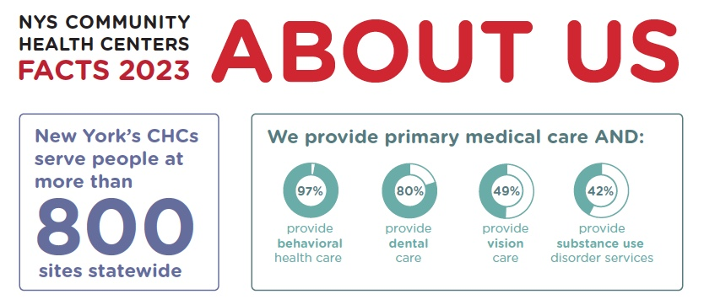

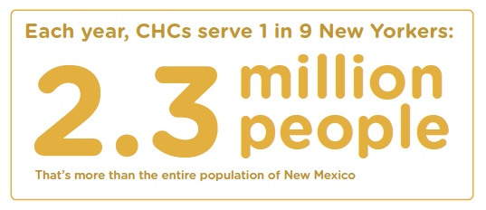
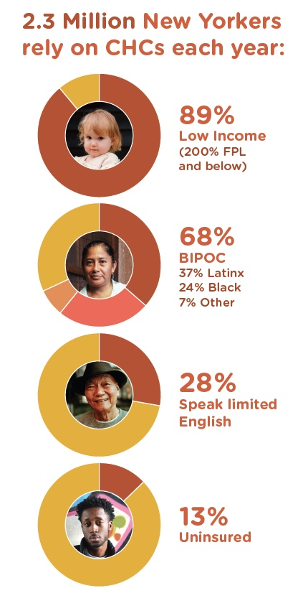

340B Images

