**National Health Center Week 2023: Social Media Template**

**Thursday, July 20th: Celebrating NYS CHCs!**

* Calling all New Yorkers! #NHCW23 is just around the corner, and we're shining a spotlight on our outstanding CHCs in NY. From providing high quality care to all regardless of ability to pay, immigration status, and insurance status, they're the driving force behind healthier communities. #NHCW23 #ValueCHCs
* With #NHCW23 fast approaching, today we are appreciating the incredible work of our NY CHCs that serve more than 2.3M patients a year. CHCs’ innovative approaches, compassionate care, and dedication are the keys to building a healthier future! #NHCW23 #ValueCHCs
* Join us today in honoring New York State's incredible Community Health Centers with #NHCW23 right around the corner. CHCs’ unwavering commitment to improving healthcare is the roadmap to a stronger America! #NHCW23 #ValueCHCs
* New York State's Community Health Centers are paving the way for a healthier and more inclusive America. As we come together for #NHCW23, let's recognize their role in breaking down barriers, reducing disparities, and ensuring that healthcare is a right for all. #ValueCHCs

**Sunday, 8/6: Public Health in Housing Day**

* Today is Public Health in Housing Day and health centers across the country are highlighting how providing access to stable housing improves health outcomes and reduces healthcare costs. #NHCW23 #ValueCHCs
* Healthy New Yorkers start with access to safe and affordable housing! #NHCW23 #ValueCHCs
* Access to safe and affordable housing is critical to improving health outcomes. Yet, almost 92,000 New Yorkers are experiencing homelessness on any given night. All New Yorkers deserve access to affordable housing and healthcare! #NHCW23 #ValueCHCs
* Health centers know that access to affordable, safe, and stable housing is critical to improving health outcomes and building healthy communities. Join health centers today in raising the importance of housing and health! #NHCW23 #ValueCHCs

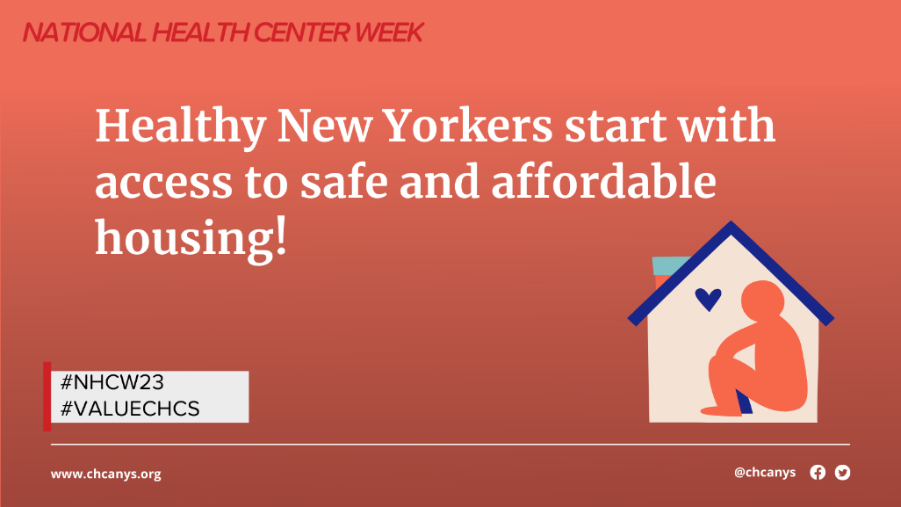

**Monday, 8/7: Healthcare for the Homeless Day**

* Today, for National Health Center Week, health centers are raising awareness on the importance of providing healthcare for the homeless. Everyone deserves access to affordable, quality healthcare and a chance to live their healthiest life #NHCW23 #ValueCHCs
* Each year, NYS CHCs serve more than 94,000+ individuals experiencing homelessness. CHCs are the safety net for healthcare for low-income and medically underserved communities throughout the country. #NHCW23 #ValueCHCs
* CHCs are critical access points to affordable, quality healthcare for people experiencing homelessness who often have difficulty accessing mainstream healthcare #NHCW23 #ValueCHCs
* People experiencing homelessness experience higher rates of chronic and acute disease, mental health issues, and other health conditions. CHCs provide critical continuity of care to ensure that people experiencing homelessness are addressing their health issues #NHCW23 #ValueCHCs

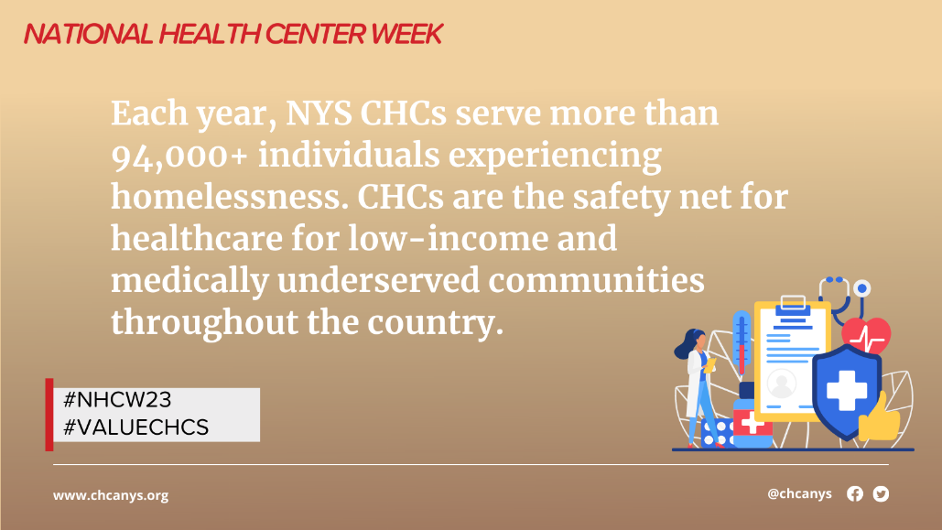

**Tuesday, 8/8: Agricultural Worker Health Center Day**

* Today is National Health Center Week: Agricultural Worker Health Day! CHCs across the country provide primary and preventative care to more than 1 million migratory and seasonal agricultural workers per year #NHCW23 #ValueCHCs
* CHCs are a critical access point for healthcare and social services for agricultural workers. CHCs serve approximately 20% of the estimated 4.5 million Agricultural Workers in the United States #NCHW23 #ValueCHCs
* CHCs and Migrant Health Program grantees ensure access to quality primary and preventive care for agricultural/migrant workers who might otherwise go without care #ValueCHCs #NHCW23
* National Health Center Week: Agricultural Worker Health Day! Let’s celebrate our agricultural workers - the backbone of America’s agricultural operations and without whom we wouldn’t have fresh fruits and vegetables on our tables. #NHCW23 #ValueCHCs

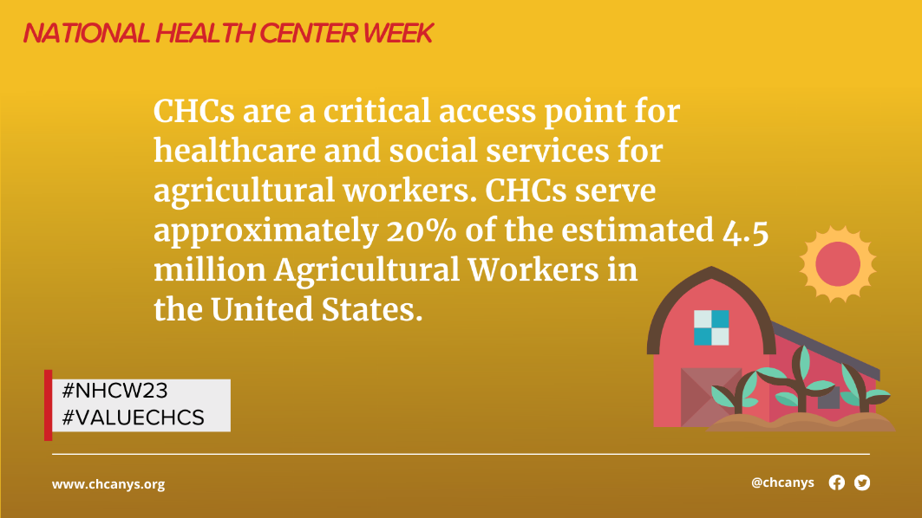

**Wednesday, 8/9: Patient Appreciation Day**

* Today is Patient Appreciation Day! Did you know that CHCs are community-run, with over 50% of Board members comprised of patients of the health center, ensuring the CHCs are patient informed, and patient governed? #ValueCHCs #NHCW23
* Over 50% of CHC Board members are comprised of CHC patients. These patients are individuals who live in the community served by the health center and are dedicated to representing the needs and voices of the community #ValueCHCs #NHCW23
* Today and every day, we celebrate patients and community board members who keep health centers accountable and abreast of community needs. #ValueCHCs #NHCW23
* CHC patients are the greatest advocates of CHCs! [Click here](https://www.chcanys.org/remote-video/2023-chcanys-advocacy-week-patient-voices-panel) to hear from CHC patients about the life changing care they receive at their CHCs #ValueCHCs #NHCW23

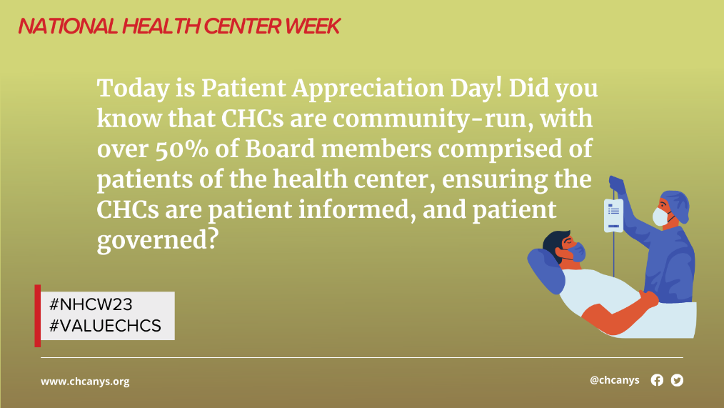

**Thursday, 8/10: Stakeholder Appreciation Day**

* For #NHCW23 Stakeholder Appreciation Day, we want to recognize our CHC champions at the local, state, and federal levels who advocate on behalf of CHCs to ensure that all New Yorkers have access to quality, affordable primary and preventive care! #ValueCHCs
* In honor of #NHCW23 Stakeholder Appreciation Day, we want to shine a spotlight on the incredible organizational and coalition partners who help to advance CHC priorities! Thank you **@XXXX** for your incredible leadership and partnership! #ValueCHCs
* In honor of #NHCW23 Stakeholder Appreciation Day, we want to thank **@XXXX** for your incredible leadership and partnership! Because of your partnership and support, we are able to advance CHC priorities! #ValueCHCs
* Thank you **@XXXX** for being a community health center champion! Because of you, we can keep our doors open and lights on to provide critically needed healthcare services to the communities that need it the most #NHCW23 #ValueCHCs

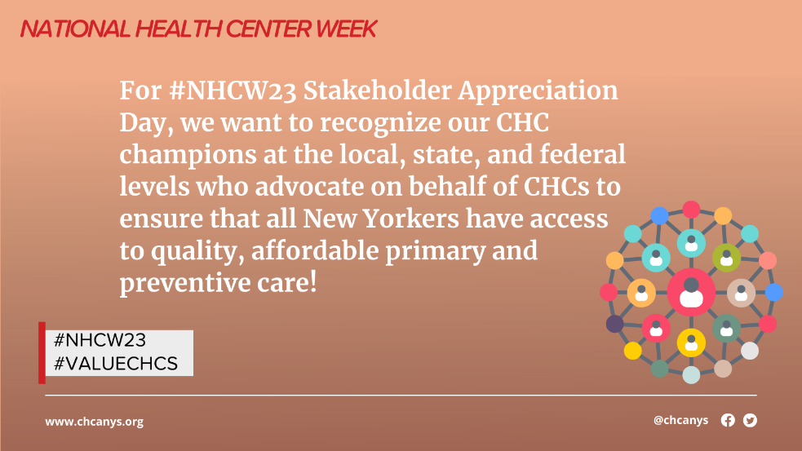

**Friday, 8/11: Health Center Staff Appreciation Day**

* Today is #NHCW23 Health Center Staff Appreciation Day and we want to express our continual appreciation and thanks for the incredible CHC staff and volunteers who work tirelessly to ensure all NYers have access to high quality primary and preventive care #ValueCHCs
* CHCs bring incredible value to their patients and communities and it’s all because of the diligent work of health center staff and volunteers who are dedicated to providing high quality care to patients in need. #ValueCHCs #NHCW23
* CHC staff and volunteers are the reason why CHCs are able to provide high quality, affordable healthcare to all day in and day out. THANK YOU CHC staff and volunteers for your dedication and commitment to the Community Health Center Movement! #NHCW23 #ValueCHCs
* Let's give a big round of applause to New York State's Community Health Centers, the heroes of our healthcare system! During #NHCW23, we celebrate their tireless dedication to providing accessible, equitable, and patient-centered care! #ValueCHCs

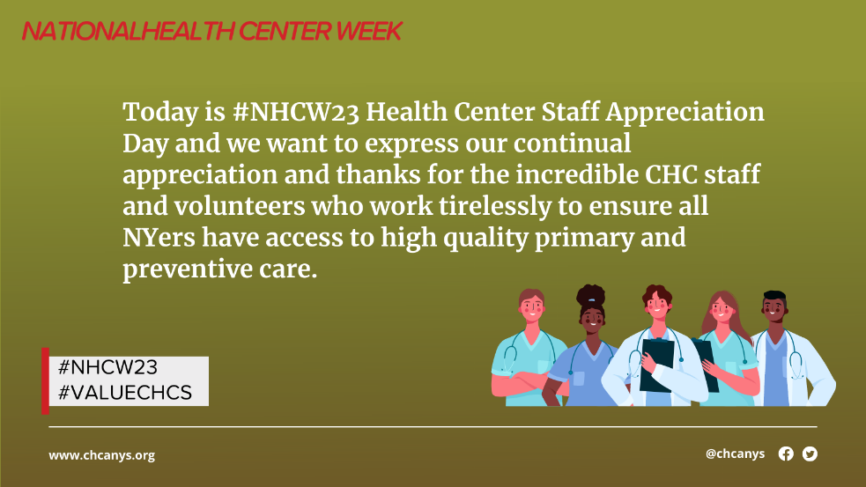

**Saturday, 8/12: Children’s Health Day**

* This #NHCW23 Children’s Health Day, we are raising awareness on the importance of engaging children and families on health and wellness so that they can be empowered to make informed decisions about their health #ValueCHCs
* CHCs provide primary care to more than 8.6 million children in the United States. Ensuring that our youngest patients receive the care they need any time whenever they need it. But especially as they prepare their return to school! #ValueCHCs #NHCW23
* From well-child checks to book drives to fun runs, health centers host events and provide resources that will help children feel healthy, happy, and empowered now and in the future. #NHCW23 #ValueCHCs

