Developing a Guiding Coalition for Change

Key Questions/Considerations

- Who needs to be included to drive the change?

- Who are the key stakeholders who have vested interests or concerns about this change? List them in one of the four categories below:
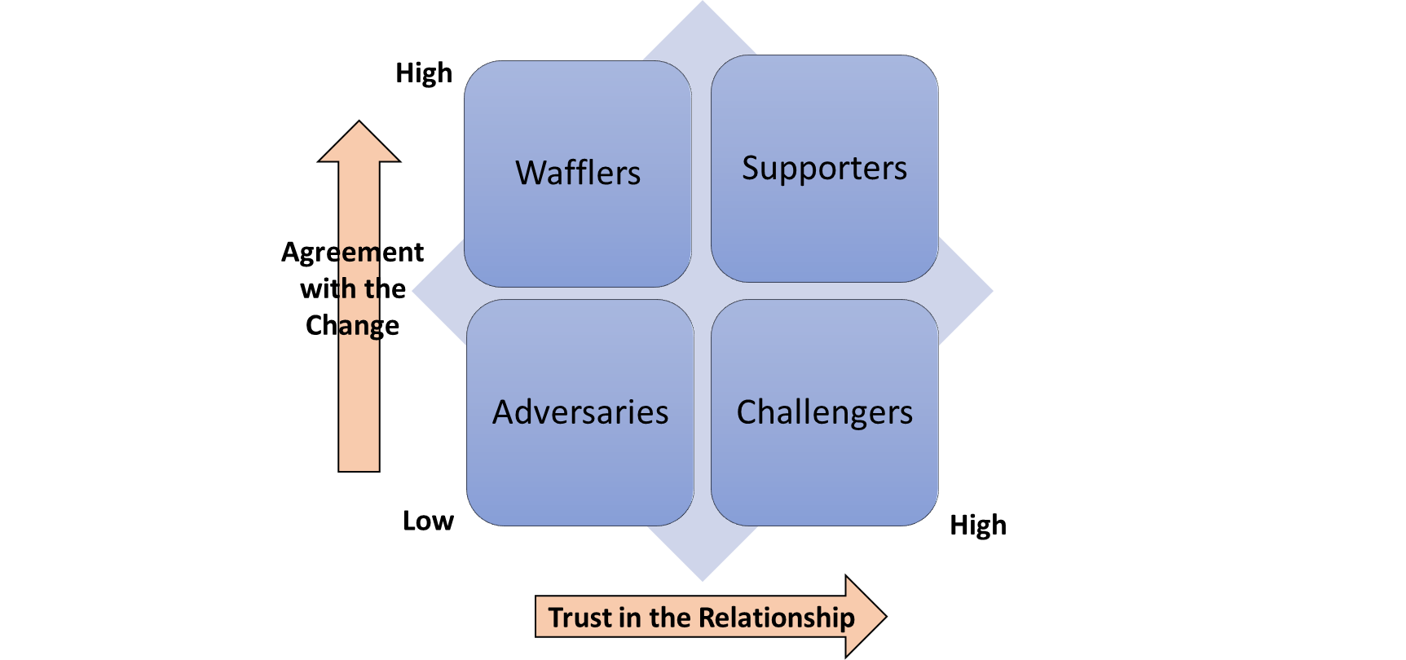

- Which stakeholders will experience benefits from the change? What benefits?

- Which stakeholders will experience burdens from the change? What burdens?

- Are any stakeholders likely to change their position or attitude toward the change? Who needs to be sold on why the change is needed?

- How much power and influence does each stakeholder have in their organization?

- What leadership and influence will it take to influence the stakeholders to support the change?

- How will the change add value for the stakeholders and consumers?

- What will people do differently as a result of the change?

- Who will be the key communicator of the vision for this change?

- Identify the driving forces (issues, structures, people, and practices) which can support the change and determine how to maximize these forces.

- Identify the restraining forces which will act against the change and determine how to minimize them.

