National Health Center Week: Social Media Template Messages
Sunday, 8/7: Public Health in Housing Day
- Today is Public Health in Housing Day and health centers across the country are highlighting how providing access to stable housing improves health outcomes and reduces healthcare costs. #NHCW22 #ValueCHCs
- Healthy New Yorkers start with access to safe and affordable housing! #NHCW22 #ValueCHCs
- Providing access to stable housing is critical to improving health outcomes. Yet at least 92,000 New Yorkers are experiencing homelessness. All New Yorkers deserve access to affordable housing and healthcare! #NHCW22 #ValueCHCs
- Access to affordable, safe, and stable housing is critical to improving health outcomes and building healthy communities. And health centers are an important resource in many communities to connect patients to housing resources #NHCW22 #ValueCHCs
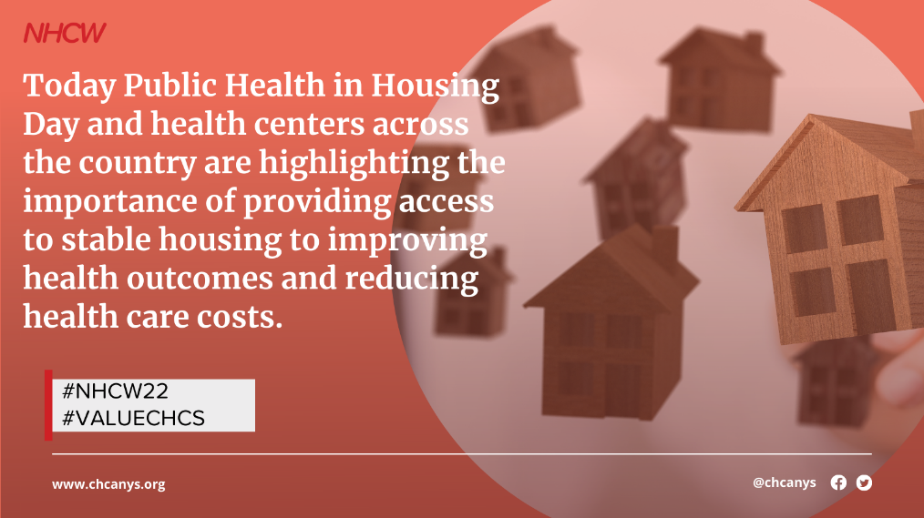

Monday, 8/8: Healthcare for the Homeless Day
- Today, for National Health Center Week, health centers are raising awareness on the importance of providing healthcare for the homeless. Everyone deserves access to affordable, quality healthcare and a chance to live their healthiest life #NHCW22 #ValueCHCs
- Health centers are the safety net for healthcare for low-income and medically underserved communities throughout the country. Each year, health centers serve 1.3 million individuals experiencing homelessness #NHCW22 #ValueCHCs
- CHCs are an important access point to affordable, quality healthcare for people experiencing homelessness who often have difficulty accessing mainstream healthcare #NCHW22 #ValueCHCs
- People experiencing homelessness experience higher rates of chronic and acute disease, mental health issues, and other health conditions. CHCs provide critical continuity of care to ensure that people experiencing homelessness are addressing their health issues #NCHW22 #ValueCHCs
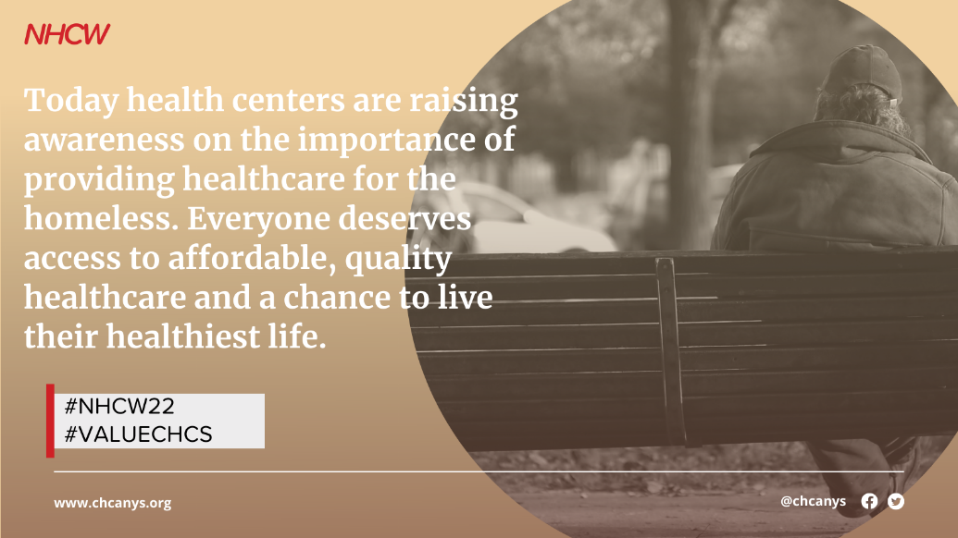

Tuesday, 8/9: Agricultural Worker Health Day
- Today is National Health Center Week: Agricultural Worker Health Day! This year also marks the 60th anniversary of the passage of the Migrant Health Act, the landmark agreement which would later lead to the Community Health Center Program. #NCHW22 #ValueCHCs
- CHCs are a critical access point for healthcare and social services for agricultural workers. CHCs serve approximately 20% of the estimated 4.5 million Agricultural Workers in the United States #NCHW22 #ValueCHCs
- CHCs and Migrant Health Program grantees ensure access to quality primary and preventive care for agricultural/migrant workers who might otherwise go without care #ValueCHCs #NCHW22
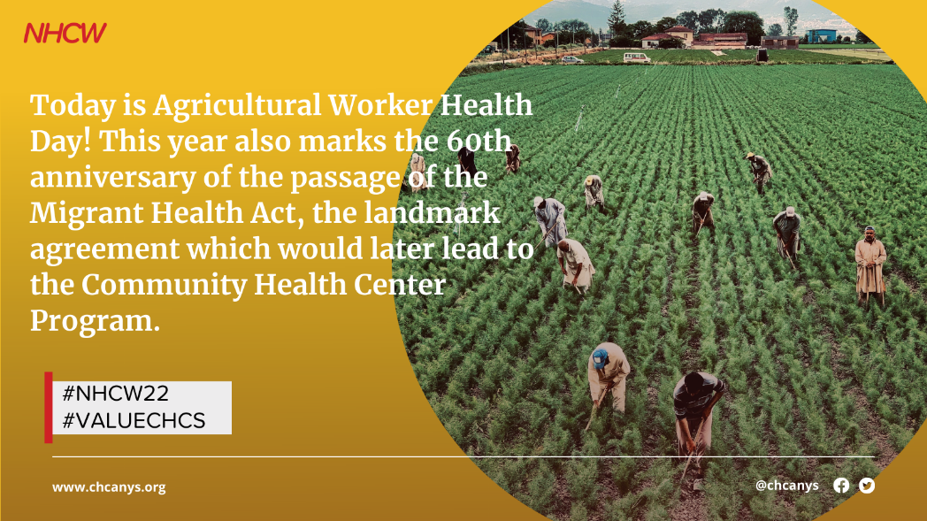

Wednesday, 8/10: Patient Appreciation Day
- Today is Patient Appreciation Day during National Health Center Week! Did you know that CHCs are community-run, with over 50% of Board members comprised of patients of the health center, ensuring the CHCs are patient informed and patient governed? #ValueCHCs #NCHW22
- Over 50% of CHC Board members are comprised of CHC patients. These patients are individuals who live in the community served by the health center and are dedicated to representing the needs and voices of the community #ValueCHCs #NCHW22
- Today and every day, we celebrate patients and community board members who keep health centers accountable and abreast of community needs. #ValueCHCs #NCHW22
- CHC patients are the greatest advocates of CHCs! Click here to hear from 4 CHC patients about the life changing care they receive at their CHCs #ValueCHCs #NCHW22
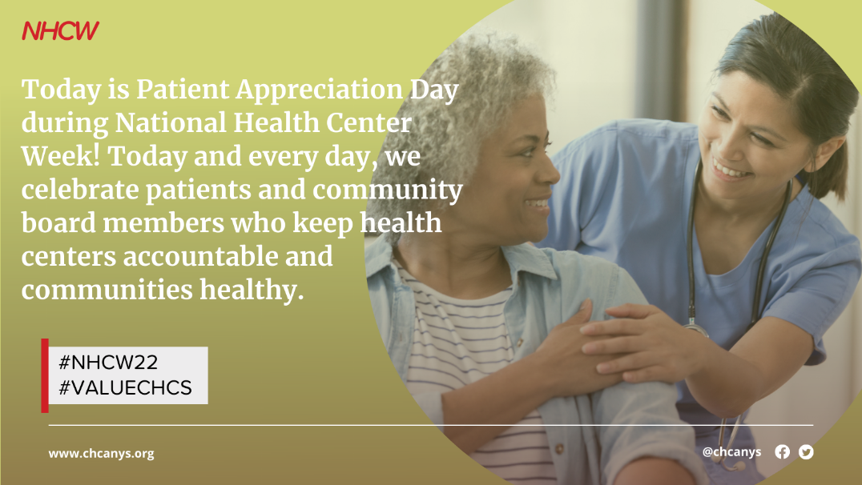

Thursday, 8/11: Stakeholder Appreciation Day
- For #NHCW Stakeholder Appreciation Day, we want to recognize our CHC champions at the local, state, and federal levels who advocate on behalf of CHCs to ensure that all New Yorkers have access to quality, affordable primary and preventive care! #ValueCHCs
- In honor of #NHCW Stakeholder Appreciation Day, we want to shine a spotlight on the incredible organizational and coalition partners who help to advance CHC priorities! Thank you @xxx for your incredible leadership and partnership! #ValueCHCs
- Thank you @XXXX for being a community health center champion! Because of you, we can keep our doors open and lights on to provide critically needed healthcare services to the communities that need it the most #NHCW #ValueCHCs
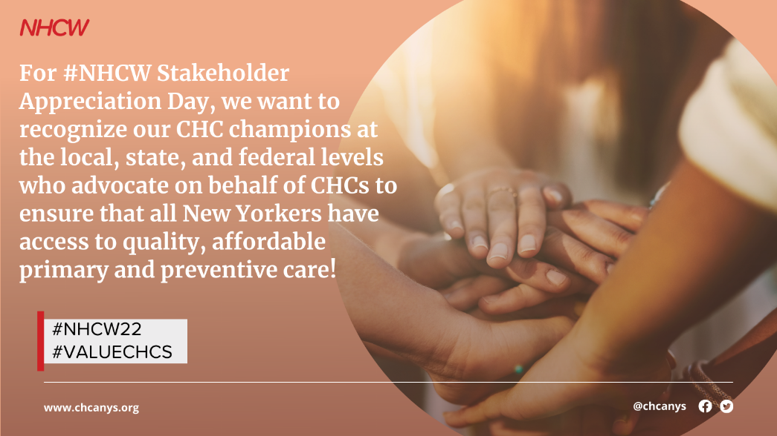

Friday, 8/12: Health Center Staff Appreciation Day
- Today is #NHCW Health Center Staff Appreciation Day and we want to express our continual appreciation and thanks for the incredible CHC staff and volunteers who have worked tirelessly throughout the pandemic to ensure all NYers have access to healthcare #ValueCHCs
- The community health centers bring incredible value to their patients and communities and it’s all because of the diligent work of health center staff and volunteers who are dedicated to providing high quality care to patients in need. #ValueCHCs #NCHW22
- CHC staff and volunteers are the reason why CHCs are able to provide high quality, affordable healthcare to all day in and day out. Thank you CHC staff and volunteers for your dedication and commitment to the Community Health Center Movement! #NHCW2022 #ValueCHCs
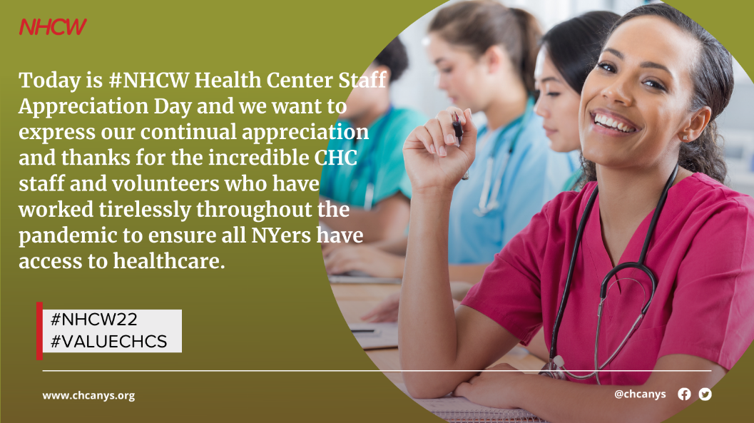

Saturday, 8/13: Children’s Health Day
- This #NHCW Children’s Health Day, we are raising awareness on the importance of engaging children and families on health and wellness so that they can be empowered to make informed decisions about their health #Value CHCs
- CHCs provide primary care to more than 8 million children in the United States #ValueCHCs #NHCW2022
- From well-child checks to book drives to fun runs, health centers host events and provide resources that will help children feel healthy, happy, and empowered now and in the future. #NHCW2022 #ValueCHCs
