Virtual Care Team Guidance for Health Centers
Contents
Introduction 2
Forming and Formalizing the Virtual Care Team 2
Virtual Care Team Communications – Best Practices 5
Teamness 8
Virtual Care Team – Essential Tools of the Trade 8
Telehealth Processes and Workflows for the Virtual Care Team 9
Consent 13
Equity 14
Telehealth Barriers and Potential Solutions for Patients 14
Person-Centeredness 16
Patient Safety – Tips for the Virtual Care Team 17
Quality Improvement and Quality Assurance 18
HIPAA Privacy and Security: Virtual Care Team Considerations 19
Resources 21
Appendices 23

This resource is supported by the Health Resources and Services Administration (HRSA) of the U.S. Department of Health and Human Services (HHS) as part of an award to CHCANYS’ New York State Health Center Controlled Network (NYS-HCCN) totaling $3,276,000 with 0% financed with non-governmental sources. The contents are those of the author(s) and do not necessarily represent the official views of, nor an endorsement, by HRSA, HHS, or the U.S. Government. For more information, please visit HRSA.gov.

Introduction
During the COVID-19 pandemic, there was an urgent need to provide and expand virtual care to continue uninterrupted health care service delivery to enhance access, support patients and families, and prevent spread of COVID-19. This resulted in a rapid increase in the delivery of virtual care in health centers and growth of virtual care teams and hybrid models where some team members are virtual – either stationary or mobile – while others are onsite. This guide provides helpful guidance, checklists, resources and best practices to optimize and support virtual and hybrid care teams. While challenging at times to separate the two, there are two sections in the toolkit, both of which are important yet separate components. Section 1 – Teaming as a Virtual Care Team covers how the virtual care team effectively communicates and functions as a team when not in person or all in the same place. Section 2 – Optimizing Team-Based Care When Not in Person covers how the team delivers health care services and support to patients or team member(s) when not onsite.
This is a starting place; the vision for the guidance document is that it will be improved and expanded as virtual care teams learn how best to coordinate and be effective and grow their capabilities to elevate the concept of team-based care in a post-COVID world where telehealth and virtual services will be the norm.
SECTION 1: Teaming as a Virtual Care Team

Forming and Formalizing the Virtual Care Team
This section is not related to providing services to patients; it is specific to forming and formalizing the team that provides care virtually – a subtle but important distinction from SECTION 2 – Optimizing Team-Based Care When Not in Person. It is quite possible that there is no need to form/formalize the virtual care team and that doing so inserts unnecessary complexity. The virtual care team includes health center staff who conduct some or all of their work offsite using audio, video, email, and direct messaging. The virtual care team will essentially be the same as the in-person or onsite care team. All team members should adhere to system-wide preferred communication norms, engage in feedback and improvement efforts, and act as back-up, if needed. Below are potential members of the virtual care team and suggestions of possible enhanced responsibilities specific to team communication and functioning (for the most part). Note that these are starting places to consider and are not recommendations. For example, behavioral health providers – for a variety of reasons – may not want to be responsible for the well-being of the team.
Virtual Care Team Member | Potential Enhanced Responsibilities on the Virtual Care Team
Behavioral health provider(s) | - Understand how the virtual care team structure impacts delivery of behavioral health care/treatment  - Ensure fidelity to whole-person team-based care (e.g., pre-visit planning huddling, warm hand-offs etc.)  - Provide targeted and immediate feedback on improvement opportunities  - Provide expertise on integrating behavioral health care into the workflow  - Monitor safety and quality issues inherent in providing behavioral health care in virtual settings
Medical provider(s) | - Act as the virtual care team lead or co-lead; may also act as executive sponsor depending on position (e.g., medical director)  - Monitor for safety and quality issues inherent in virtual settings  - Provide targeted and immediate feedback on improvement opportunities  - Message to patients about the virtual care team model and opportunities  - Help establish and reinforce system-wide preferred communication norms  - Reinforce mission, vision and values and how the team fits in and strengthens the organization
Registered nurse (RN) | - May act as the virtual care team lead or co-lead; may also act as executive sponsor depending on position (e.g., Chief Nursing Officer)  - Be on hand/join call for situations that require RN assistance, input or triage
Medical assistant (MA)/licensed practical nurse (LPN) | - Ensure fidelity to in-person team-based care (e.g., pre-visit planning, huddling, patient intake/education, documentation)  - Plan, lead and improve virtual huddles
Reception staff | - Understand how the virtual care team structure impacts duties assigned to reception staff (e.g., intake, consent, demographics)
Billing staff | - Understand how the virtual care team structure impacts billing, coding and collection of patient payments
Dental hygienist and other dental staff | - Understand how the virtual care team structure impacts oral health care operations
Other important team members | Consider if and how others who work virtually are included on the virtual care team: community health workers, pharmacists, and others.

As the virtual care team is forming and coalescing, here are a few action items or steps to consider.
Assign an executive sponsor. Incorporating a designated executive sponsor that is in a leadership role demonstrates leadership engagement, support and validation for the team. The role of the executive sponsor is to:
- Help the team remove barriers that impede their effectiveness
- Clarify the team’s agency – i.e., what is the realm of decisions they can make on their own vs. decisions that need higher input/approval?
- Act as the final arbiter of decisions or to facilitate those decisions for the team, including for policies, procedures, processes, etc.
- Deliberately tie the work into the rest of the health center operations to ensure integration across all locations, teams, service lines (e.g., primary care, behavioral health, oral health/dentistry)
- Incorporate the virtual team - its success and viability - into strategic planning to ensure sustainability and continued effectiveness
Identify a team lead. Starter list of responsibilities for the team lead include:
- Represent and advocate for the team
- Act as point person for questions from the team
- Help the team develop goals, draft a charter, find the team’s norms, etc.
- Lead meetings
- Monitor team functioning and dynamics
- Address team dysfunctions – absence of trust, fear of conflict, lack of commitment, avoidance of accountability and inattention to results.
- Ensure the team fosters positive regard and celebrates successes
- Capture and share virtual care team best practices
Create the team roster. Identify who is on the team with credentials, roles and contact information at a minimum. Some teams like to personalize and add a few biographical or fun facts for each member of the team. The team roster does not have to be a table in a Word document buried in a file somewhere. It can be reflected in an email distribution list, texting list or even as a group list on a communication app like WhatsApp. This roster or list defines any staff member (e.g., provider, medical assistant) that provides virtual care even if part of their time is spent at the clinic (hybrid model). Consider including community health workers/promotoras and others. This also forms the master list for communications.
Revise or create a virtual care team compact or charter. If the team is truly a team and not a group of people working together, the team should share a common goal(s), which can be further articulated in the compact. For each goal, it is reasonable to ask, “How will we know if we have achieved our goal(s)?”
TIP: Be cautious about developing goals that start with action verbs, which may reflect how the team will achieve the goal(s) rather than the goal itself.
Sample Virtual Care Team Goal(s):
Regardless of whether we are onsite at clinic, in our homes, at a patient’s home or elsewhere, the virtual care team goals are:
- Team-based health care services that are person-centered, equitable, safe, high quality and efficient.
- Continuity of patient care and information.
- Accessibility of health care services for patients and accessibility of the virtual team to patients and staff.
- Continuous improvement.

Redefine (or define) roles and responsibilities. Review existing written job descriptions, roles and responsibilities and assess whether there are additions or changes that need to be made for those on the virtual/hybrid care team. Include team members in the review and update of roles and responsibilities.
Because the virtual care team model is relatively new to most health care organizations, it is important to ensure everyone is aligned on the expectations for their role and that there are no gaps that can adversely impact patient or staff experience, safety, quality or efficiency. Consider how having a team member that works across teamlets will function virtually on a given day or week. Know that with a hybrid model a person may work partially in person and partially virtual, or the care team may have some people working in person and some people working virtually on a given day or week. It may end up being easier or more complex but is important to work out in advance to avoid chaos and misunderstanding. Consider including in huddles: who is on the team today, and where are they?
Clarify team expectations. Add to this starter list and customize to your health center and staff.
- Ensure the privacy and security of patient information (more details below in HIPAA Privacy and Security)
CONSIDER: Include team expectations in the team compact.
- Respond to nonurgent emails within three business days and urgent emails within one day
- Respond to texts and phone calls as soon as possible but by the end of the working day at the latest
- Create a dedicated working space if appropriate if you are not working at clinic
- Be immediately available (if possible) during working hours if not in clinic
- Be courteous and professional in all virtual communications – to everyone at all times
- Ask for help when you need it; we are a team!

Virtual Care Team Communications – Best Practices
As more health care is delivered and coordinated virtually, it is important to consider the impacts to the communication among the virtual care team, providers, patients and others. Asynchronous communication (e.g., texts, messaging within the EHR, emails) is fraught with possibilities for error and misinterpretation. Synchronous communication (e.g., phone call, video conferencing, in-person meetings) is better for certain transfers of information but is more time-consuming and can be more challenging.
Consider some general guidelines around when each type of communication is most appropriate. This is a starter list.
Synchronous communication  - Critical labs or other tests  - Anything with any emotion  - Need for immediate response or information sharing  - Any situation related to patient or others’ safety | Asynchronous communication  - Information that is not time-sensitive  - Huddles/pre-visit planning information  - Availability in the moment (e.g., “Are you ready to jump on the telehealth visit?” “Are you available for a consult or warm handoff?”)

ASYNCHRONOUS COMMUNICATION BEST PRACTICE: Use the Situation-Background-Assessment-Request/Recommendation (SBAR) method of communication whenever possible for emails, text messages, and other electronic written communications. Not only is this an established method of communicating in the health care setting (originally developed by the military), but it also helps prevent rambling, disorganized written communications. If leadership and others start modeling and then requesting this type of rigor with communication, staff pick it up quickly and get better at it with practice. Keep in mind that there are broad uses for SBAR and that the R can either be a request or a recommendation. Using SBAR for streamlined communication does not need to be fussy or require a template.

SBAR Example – MA to Physician – message in EHR:

Situation: Ms. Z says she lost her Ativan prescription and wants a new script.
Background: She is your patient, and you saw her two months ago. She recently lost her husband to a tragic accident and was prescribed Ativan by an ED physician who treated her husband when he came in and subsequently died in the ED. I ran a prescription monitoring program (PMP) report on her, and there are no controlled substances on the report.
Assessment: Based on the above information, she will benefit with small number of Ativan pills and referral to counseling. She is at low risk of addiction/diversion.
Request/recommendation: Let me know if you will prescribe Ativan 1 mg x 10 pills for her. I will refer for grief counseling; please cosign the referral when I route it to you.

Resources:
SBAR. Wikipedia. Provides additional information on SBAR.

SBAR – a powerful tool to help improve communication!. The Joint Commission. 2013. Includes simple descriptions of the information to include for each of the components.
SBAR Tool. Institute for Healthcare Improvement. 2017. This resource is a bit narrowly focused but still helpful.

Email. Not everyone is comfortable with email as a primary mode of communication, especially if working virtually is not what they ordinarily do. Know who may be relatively new and support them; one email-savvy person can take a few moments to orient those new or newish to email and/or be the go-to person when newbies are trying to figure out how to accomplish something within email.
TO field: Decide who really needs to be included in the email and err on the side of inclusivity if that is the preference of the team.
CC field: Carefully decide who needs to be copied to keep them in the loop. People who are copied on an email are not expected to take any action or reply to the message; it can be helpful to reinforce this general rule. Some people also use this field as a signal to the recipient that others are copied to ensure urgent action or that the content needs to be taken seriously. Occasionally it is helpful to clarify why someone has been copied (e.g., “I’m copying Alice just to let her know we’re working on this. OK to drop her off subsequent replies.”)
BCC field: This option is great when sending to a large group; it also prevents the email clutter and chaos when recipients “reply all”. Some people use blind copy when they want to hide that they also copied someone else on the email. These should be rare occasions.
Subject: Consider how the subject line can convey information and help the recipient. For example: “Availability” provides less information than “Your Availability to Lead the Staff Meeting Next Thursday”.
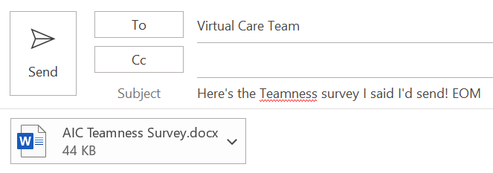
Implement the EOM or end-of-message option among the team members, which has been shown to increase productivity. It is a short message in the subject followed by EOM to signal to the recipient that there is no additional information in the body of the email.
Body of email: As noted above, many emails can and should be sent using the SBAR structure even if each section is not labeled – Situation, Background, Assessment and Request/Recommendation. SBAR is not only for medical information!
- Do not send patient protected health information (PHI) unless your email is secure and encrypted
- Use paragraphs. Chunk up the information.
- Do not include TBU (or true-but-useless) information.
- Read your emails at least twice for errors, but do not get hung up or take too much time to wordsmith excessively.
- Pick up the phone and do not send emails with emotion woven in or around the topic/person.
- Consider carefully how much information to include. If you ask more than one question or make more than one request, people often do not notice and will not answer/respond to everything.
Calendaring. Coordinating schedules within the team is easy if everyone shares calendars. If not or when coordinating with patients or families (e.g., online diabetes group visits, shared virtual medical visits), use online options like Doodle Poll, Calendly or another option.
CONSIDER: Not everyone is used to using and sticking to a calendar (e.g., front line staff); provide training as needed.
- When sending the invite, include the purpose for the meeting and an agenda
- Set team norms around responding to meeting invites – accept, tentatively accept or decline etc.
- Try not to send meeting information as separate emails; update or attach information to the invite and resend/update the invite so that attendees do not have to remember where an email is to access information for the meeting.
Text or instant messaging. For purposes of this document the relevance of the differences between the two is mostly insignificant. However, texting is the transmission of short messages between or among two or more mobile devices while instant messaging is more along the lines of an online chat using applications like WhatsApp, Teams, or Skype. Either way the same principles in the section on the body of emails above apply.
Phone. The health center and virtual care team should agree upon general rules, assuming those rules only apply to use of mobile phones by the virtual care team. Here is a starter set.
ABSOLUTE MUST: IT staff and/or the HIPAA Security Officer need an inventory of all personal or other mobile devices used by the virtual care team.
- Except for extenuating circumstances, do not call or text a virtual care team member about work outside of working hours
- Do not leave voice mail messages with patient PHI
BEST PRACTICE: *67 blocks the caller’s number, but patients often do not pick up for an unknown caller. Use an app or solution that displays the health center as the caller ID.
- If your phone is lost or stolen, you must notify IT staff immediately [insert how, recognizing the individual will not have their phone], and they may disable or wipe it
- Use *67 or health center-approved solution to block your number.
Virtual team meetings. While some of guidance below can apply to team huddles for patient care, this is primarily geared towards when the virtual team has a general team meeting.
- Leave some time at the beginning for idle chitchat and personal updates – 5-10 minutes open space – this has been recognized as important for team and individual well-being
BEST PRACTICE: Take real-time notes during meeting so that notes are done at the conclusion of the meeting – best if screensharing the document – everyone literally on the same page.
- Use video whenever possible
- Whether using call or audio and video, acknowledge each person’s contribution to the discussion (e.g., “Thank you, Alice.”, “We hear you.”, “Sounds good.”); this is surprisingly important when not meeting in person.
- Allow use of backgrounds if the meeting platform has this option for team members who prefer not to share the visual details of where they are
- Send the post-meeting notes to all members of the team, including those who miss a meeting; consider recording the meeting – can “date stamp” recording and delete in two weeks.
- Use all functionalities of the virtual meeting platform to encourage engagement and playfulness (e.g., raise hand, clapping hands, emojis, virtual dot voting, polls)

Teamness
For some people, working virtually is fantastic; they love the flexibility, convenience, time-savings, relief from a commute, lack of interruptions and more. However, for other individuals it can be incredibly isolating and lonely; they long for the daily camaraderie of being in-person. The challenge is to create a sense of teamness in the virtual care team. Many strategies are noted throughout this document, but the basic rule of treating others as you want to be treated, creating a culture of collaboration and acceptance, and hearing all voices go a long way to creating cohesiveness in the team. Identify and address issues early and often. Those issues can include Lencioni’s five team dysfunctions as mentioned above – absence of trust, fear of conflict, lack of commitment, avoidance of accountability and inattention to results but feelings of belonging, morale and burnout should be addressed, too.
Technostress. The term technostress has been around since at least 1984 when it was described by the psychologist Craig Brod as “Technostress: the human cost of the computer revolution”. Since then, several definitions have evolved, but most of us are familiar with what it means and why it happens. It can be a substantial contributor to burnout. While all care team members are at risk, a study in 2017 showed that clinicians may spend up to two-thirds of their time at work allocated to clerical and in box work in the EHR, providing a great opportunity to apply team-based care by the virtual care team. To learn more, search online or check the Wikipedia article Technostress. The virtual care team is at risk for technostress, and there are established physical and mental manifestations. The team should identify the plan to identify and address when individuals are suffering from technostress.
BEST PRACTICE: Take a few moments before launching into virtual meeting to check in with each other and/or lead a short mindfulness exercise or other stress buster.

Resources:
- Mini Z Burnout Survey. American Medical Association - STEPS Forward™ and AMA Burnout and Well-Being website
- Teamness Survey
- Going Home Checklist – Great one-pager to reset and relax after a stressful day.
- From the Mindfulness Toolkit – Check out this simple guide to The Mindful Breath.
- In Search of Joy in Practice: A Report of 23 High-Functioning Primary Care Practices. Ann Fam Med 2013;11(3):272-278.
- Joy in Work Tools. Institute for Healthcare Improvement. Note that you need to create login to access these resources, but it is quick and easy to do so, and the resources are great.

“Psychological PPE”: Promote Health Care Workforce Mental Health and Well-Being – download a PDF of the tool and/or the great graphic.

Conversation and Action Guide to Support Staff Well-Being and Joy in Work During and After the COVID-19 Pandemic – This guide includes actionable ideas that leaders can test during and after the pandemic to build strong foundations to sustain joy in work for staff.

IHI Framework for Improving Joy in Work – There is something for everyone in this white paper to help identify and address burnout in the workplace and to bring back joy.
- Emotional Well-Being and Staff Resilience: Navigating the Covid-10 Pandemic ~ 20-minute video.
- Mini Meditation Unwind from Headspace One-minute video about how to breathe and be mindful.
- 2 Minute Re-Centering Mindfulness Meditation for De-stressing Self explanatory
- Code Lavender: A tool for staff support from the Cleveland Clinic

SECTION 2: Optimizing Team-Based Care When Not in Person

Virtual Care Team – Essential Tools of the Trade
High-performing virtual care teams need a short list of essentials to be successful. Consider how best your health center can provide the following. Consider adding that status of each of these for each member on your team roster (i.e., have/don’t have everything needed).
Laptop/mobile device. If the virtual care team is working from home or other offsite location, they will need a mobile device provided and maintained by the health center. This does create a security risk if devices are lost or stolen, but there are safeguards to put in place, and this is an essential tool.
Access to the electronic health record. For the virtual care team to be effective they need access to patient information, recognizing the inherent technical, security and privacy issues. Providing secure access through a virtual private network (VPN) may be a solution, but IT staff will know the best way to accomplish this.
Privacy screen. When virtual care teams work from home, there is always the risk that friends or family can see a patient’s information. Providing a privacy screen for the monitor/screen prevents purposeful or inadvertent viewing of patient information.
Teleconference and videoconference capability. It is possible that one solution will cover both requirements (e.g., Zoom).
Reliable, high-speed broadband. For interacting with patients as well as the rest of the virtual care team, a reliable connection is a MUST.
Strong phone connectivity. In rural areas this is a perennial problem, and while 5G holds promises, it is not here yet. Solutions include boosters, using an internet-based phone solution (e.g., WhatsApp) if internet is adequate, or having the team member work in a place with better phone service, if home is not an option.
Readily available technical support. Some organizations have strong IT teams that can provide tech support while others may have that one individual who just seems to have the knack for finding solutions. Either way, the team needs to have support for when the technology is not working.

Telehealth Processes and Workflows for the Virtual Care Team
Telehealth visits are the same as in-person visits only they are conducted using audio and video. For the most part, the team should continue with the same roles and responsibilities as with an in-person visit. Many health centers have struggled to maintain team-based care and have reverted to having providers do almost everything, causing the provider to run late, adding to chaos, and contributing to stress and burnout. As with in-person visits, standard, efficient workflows are the key to having telehealth visits run smoothly and ensuring patient safety. As telehealth is being implemented, consider forming a small team of two to three individuals who are responsible for establishing, mapping, fine-tuning and continuously improving workflows.
Find a solution for huddles and pre-visit planning. Unfortunately, some telehealth or virtual visit workflows no longer include pre-visit planning to identify and address chronic and preventive gaps in care, which is a risk management and patient safety issue. Even for in-person care, each health center is incredibly individual in how they accomplish pre-visit planning. The virtual care team must identity a standard process to identify and address gaps in care even if it is to document a plan to close a gap in care after the COVID-19 pandemic is over.
Many teams have found asynchronous ways to huddle at the beginning of clinic due to the challenges of getting everyone in one place at one time regardless of working virtually. If huddles are used to convey information that is specific to a certain group and does not include patient information, email works well as do other bulk messaging options. Include in huddles who is on the team today and where they are located. Each organization needs to find a solution that works for them and their staff given available resources.
- One health center has a team of two individuals with high energy and creativity who have a quick (< 5 minute) “huddle” by Zoom in the morning and provide the recording link to staff who missed it.
- Some teams used to gather in person and then call their providers who always seem to be running late, huddling while the provider was on the way clinic. An equivalent is for the MA/LPN to have the schedule up, call the provider and lead the huddle, making notes along the way as needed.
- Other teams use messaging within the EHR or electronic stickie notes to huddle asynchronously.
Identify and address gaps in preventive and chronic care. Unfortunately, this important piece of primary care service delivery is often skipped with telehealth, placing the patient at risk for missed and delayed diagnoses and services. See Figure 3. Sample Pre-Visit Planning Workflow below.
Clarify who will document what in the patient chart and how, while optimizing team-based care. The provider needs to complete the history of present illness (HPI) (or confirm what another team member has entered for the HPI); document physical exam findings; develop the assessment and treatment plan, and; prescribe medications. Recognizing that the provider has complete responsibility, any other aspect of the visit may be delegated to someone else on the team as long as it complies with federal, state, local and organizational regulations, requirements, protocols, etc. The individual must also have the requisite skills, licensure, training and comfort level, of course.
Streamline all workflows that are patient-facing – test and test again to ensure everything is as easy as possible for patients to schedule and participate in a telehealth visit. In some cases, workflows are not easy to modify. For example, for teams using Epic, patients need to have an active MyChart account to participate in telehealth. This may be an issue for patients without an email address.
Identify situations where handoffs are likely to occur and outline the step-by-step process. Make sure that the process does not leave a provider or care team member without an option to keep working. For example, handing a device during a telehealth visit from a provider to a behavioral health specialist without another option for the provider to keep working or see the next patient is not ideal.

Figure 1. Sample Pre-Visit Planning Workflow
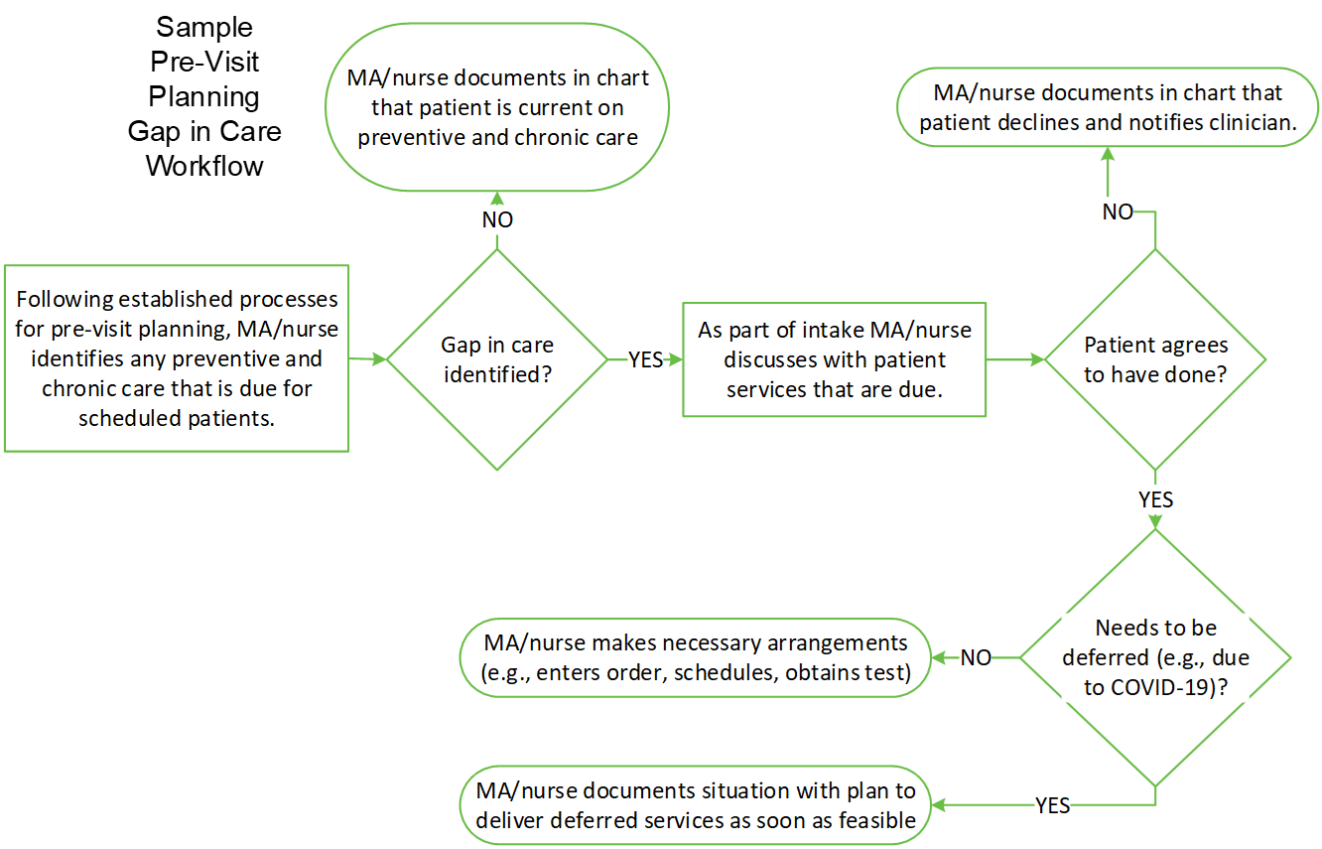

Before the Visit – Telehealth Scheduling Best Practices
- Offer telehealth as an alternate option to in-person visits when patients call for an appointment
PROMISING PRACTICE: Offer telehealth and virtual services a few times to patients who initially decline; they often decide to give it a try after a few offers.
- Create script for reception staff to message telehealth
- Provide clinical protocol for visits that are appropriate for telehealth vs. visits that must occur in-person
- Dedicate blocks of time on the schedule for telehealth visits rather than mixing in with in-person visits
- Ask all patients that are interested in telehealth, “Do you have a smartphone, tablet, or desktop computer with camera and internet?” If patients have one of the three, they can be considered “video-capable.”
BEST PRACTICE: Provide clear, written guidance for reception staff for which conditions and symptoms require an in-person visit rather than a telehealth visit.
- Document and track which patients have audio and video vs. audio-only; consider this a social determinant of health linked to equity and access to health care that may be addressable
- Offer a pre-visit technology test for those new to telehealth and/or provide patients with educational materials (e.g., website, online videos, mail, email, text)
- Consider discussing telehealth expectations with patients new to the experience – treat a telehealth visit the same as you would an in-person visit, do not multitask (e.g., while shopping. driving or walking down the street), find a quiet place, etc.
- Have telehealth materials on hand to send to the patient (e.g., 20 Things to Know about Telehealth, My Telehealth Checklist)
- Send appointment time and date to patient with instructions on how to join the telehealth visit
- Send appointment reminder per patient’s preferred method (e.g., phone call, text, email)

Figure 2. Sample Telehealth Scheduling Workflow
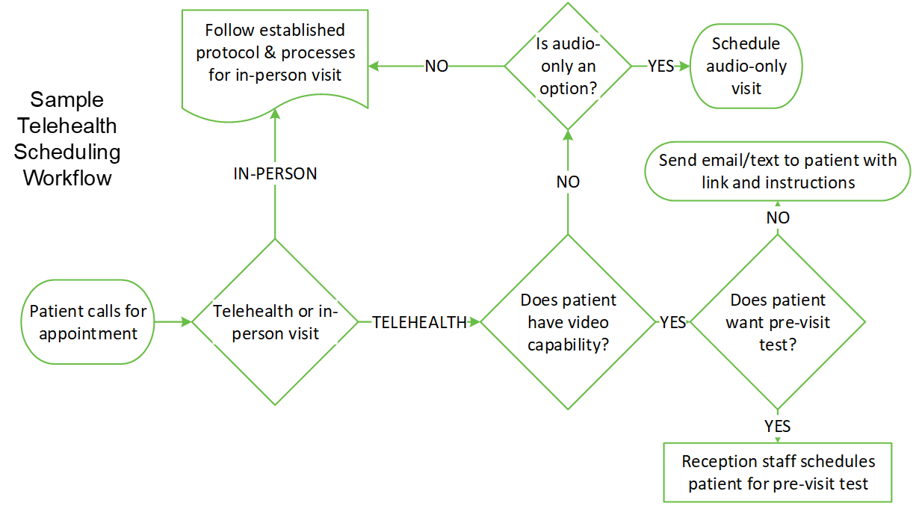
Day of the Visit – Telehealth Team-Based Care
- Start the patient visit on time! If patients have to wait for the visit to start or wait for the provider, they often cannot use their device during the wait, which can be very inconvenient if that device is their smartphone.
PROMISING PRACTICE: To avoid multiple patient handoffs, cross train MA/nurses to perform the intake that reception staff usually do for telehealth visits.
- Have MA/nurse perform as closely as possible the intake that occurs for in-person visits and add telehealth-specific intake tasks
- Verify patient identification (e.g., match to patient picture in EHR, social security number, date of birth, address, phone number)
- Review back-up plan if audio or video fails (e.g., number for team to call patient)
- Confirm address where patient is – important in case patient suffers adverse event and emergency medical services need to be called; note that patients may be in their car!
BEST PRACTICE: Many health centers struggle with when and how to collect copays. Feedback from the field suggests that collecting copays before the visit works well.
- Obtain and document consent (may differ depending on patient’s insurance)
- Advise patient about how to pay copay/deductibles
- Confirm chief complaint, collect information for history of present illness, possibly confirm patients’ list of questions
- Confirm any updates to social, family or surgical history
- Reconcile medications (for review and confirmation by provider)
- Administer any screening tests (e.g., PHQ9)
- Begin review of systems questions
- Address preventive and chronic gaps in care (if COVID-19 prevents obtaining care that is due, document the plan to obtain that care once restrictions are lifted)
BEST PRACTICE: Signal to others that you are on a telehealth visit. For example – put a sign on your door.
- Depending on the telehealth platform (e.g., Zoom), help patients with adding a background if they are self-conscious or do not want the provider/care team to see their surroundings
- Consider acting as scribe during the visit

Figure 3. Sample Warm Handoff to Behavioral Health when Everyone is not in One Place
When the team is working virtually or when the patient is on a telehealth or telephone encounter, handoffs to behavioral health can become complicated. These handoffs should be as efficient as possible and preferably should not include physicially handing a device to the behavioral health care team member if it means that the other care team members cannot continue with their work without the device (e.g., laptop or tablet).
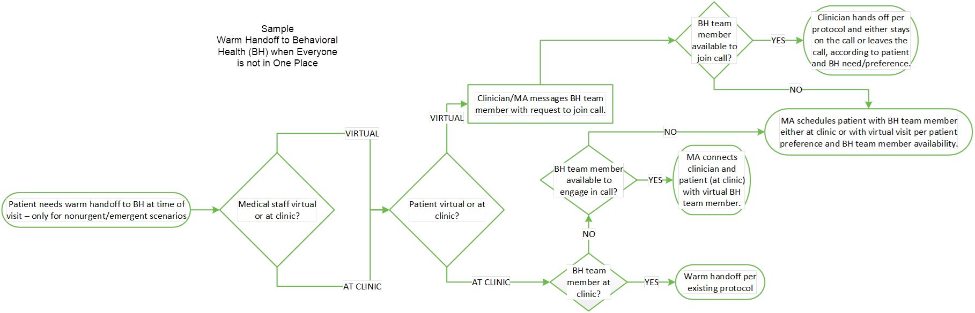

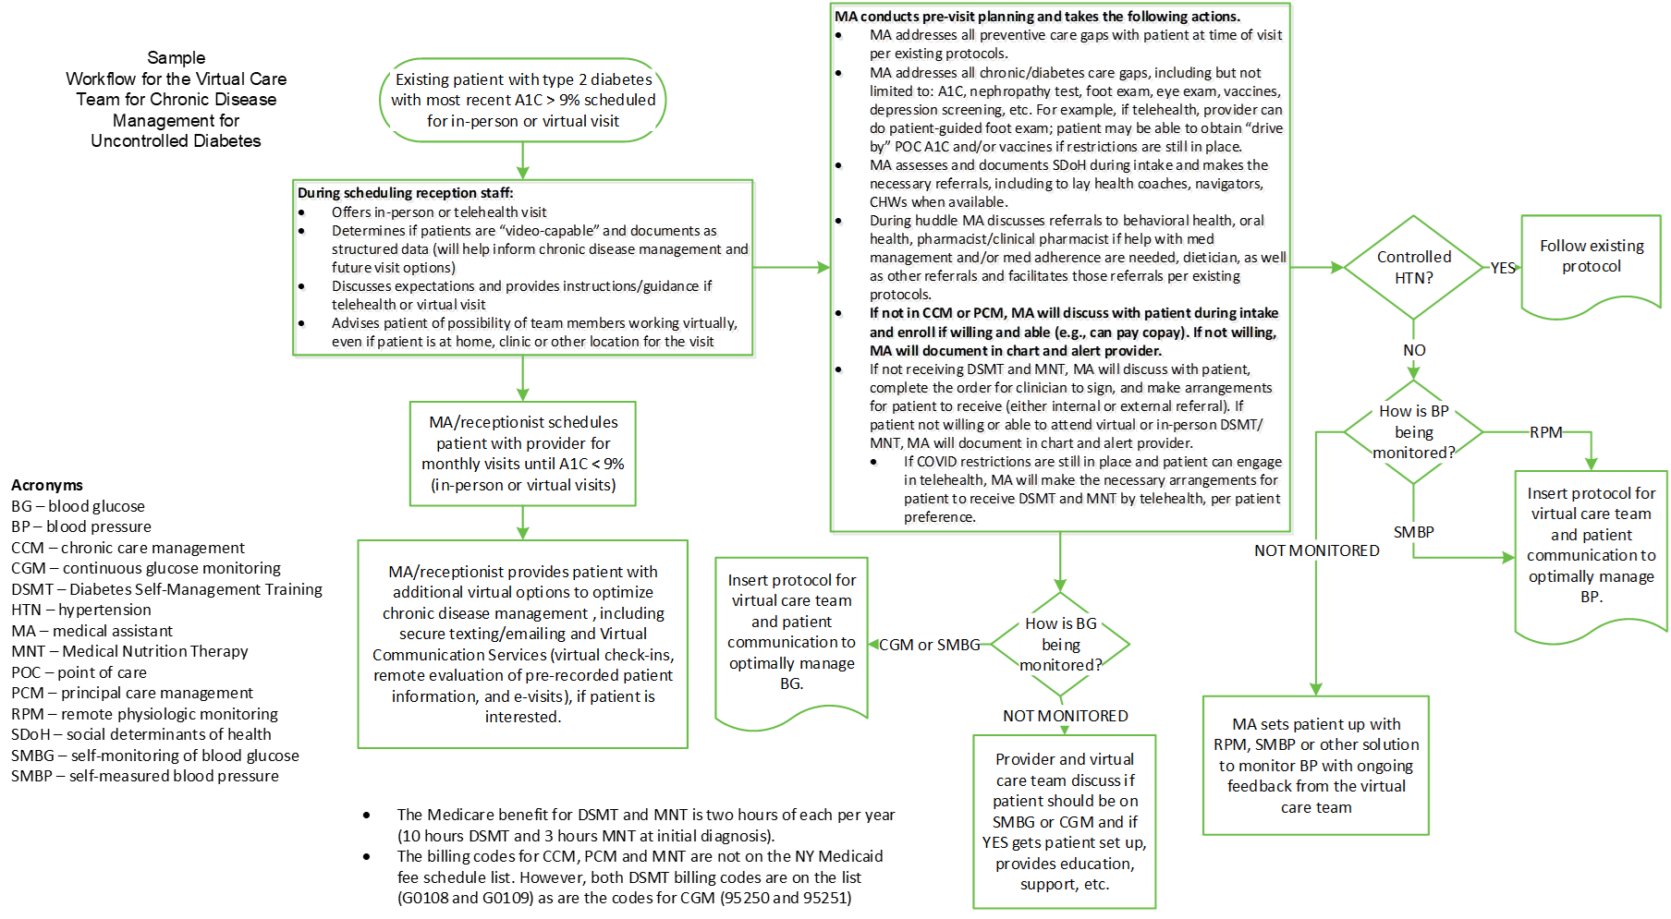
Figure 4. Sample Workflow for the Virtual Care Team for Chronic Disease Management for Individual with Uncontrolled Diabetes

Figure 5. Sample Virtual Care Team Workflow for Initiation of Treatment for Individuals with Opioid Use Disorder
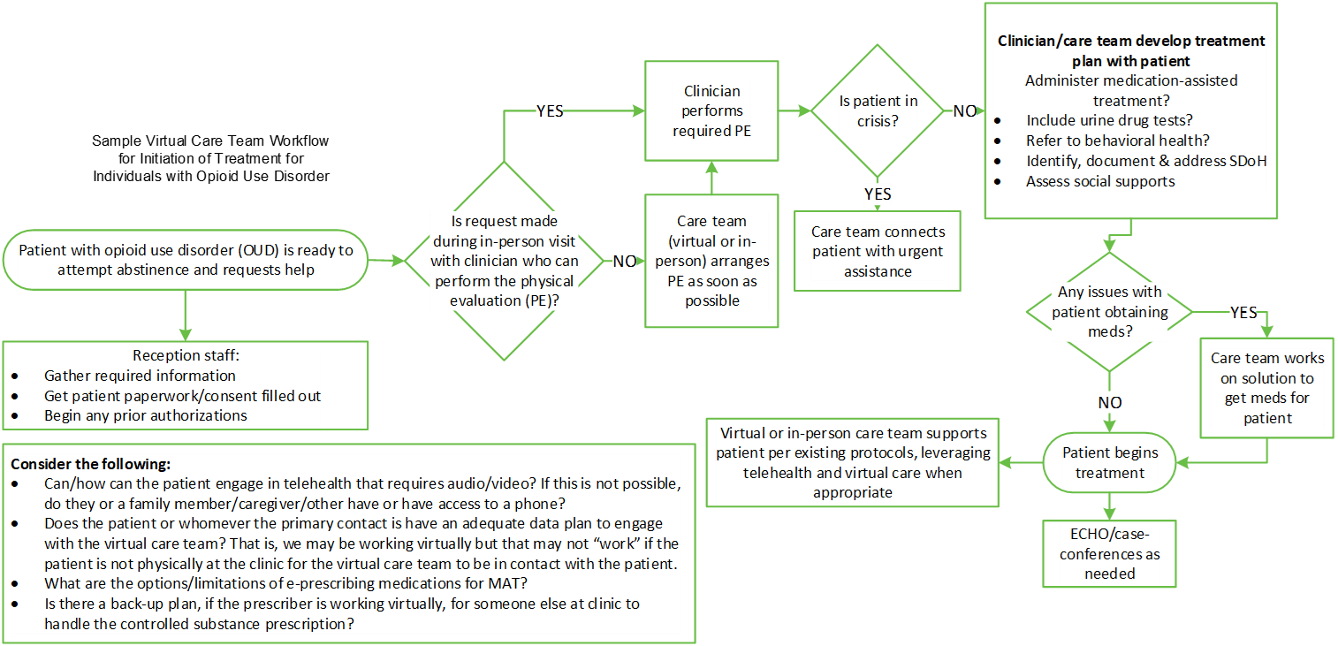
Telephone-only options. The pandemic brought health inequity into sharp focus, leading to strong advocacy to ensure that telephone- or audio-only remains an option for patients and care teams whether virtual or not. Early in 2020, CMS expanded the list of telehealth services and allowed certain codes/services to be delivered as audio-only for the duration of the public health emergency (PHE). Check the CMS List of Telehealth Services to identify which can be delivered by audio-only. The Permanency for Audio-Only Telehealth Act is pending legislation, submitted in December 2020, to create a permanent option for Medicare to reimburse for audio-only telehealth.
However, prior to the ongoing debate around audio-only for telehealth, we have always had several options to deliver audio-only billable health care services. These include but are not limited to virtual check-ins and the monthly care management options - chronic and principal care management and behavioral health integration.
PROMISING PRACTICE: While frequently overlooked, telehealth visits provide an amazing new opportunity to include family members and/or other caregivers for select patients, especially those that have cognitive impairment, intellectual disabilities and/or are a minor (e.g., if delivering school-based telehealth). There are two important caveats:
- The patient or health proxy must provide permission.
- The visit must still be focused on the patient without disruption from other participants.

Resources:
- Remote Visit Workflow Nicely done example
- Telehealth and Telephone Visits in the Time of COVID-19: FQHC Workflows and Guides
- Nice example of a step-by-step workflow including screenshots of the EHR
- Basic information on workflows can be found at the Agency for Healthcare Research and Quality website What is workflow?.
- The National Telehealth Research Center provides a 47-minute instructional video on Mapping and Designing Telehealth Clinic Workflows that covers the basics of workflow mapping.
- The California Telehealth Resource Center provides additional telehealth sample workflows
- Rapid Implementation of Telepsychiatry in a Safety-Net Health System During Covid-19 Using Lean – excellent example with nice cause-and-effect diagram and workflow

Consent
The virtual care team should obtain and document consent to receive telehealth services for all patients. Medicare, most state Medicaid agencies and other insurers require patients’ informed consent for telehealth. While consent for Medicare beneficiaries is straightforward, other insurers, including state Medicaid agencies, have informed consent requirements that can be complex. Below are the consent requirements for Medicare and NY Medicaid. Check directly with other insurers for their specific requirements and guidance for informed consent.
Medicare Consent for Telehealth
Medicare requires beneficiary consent — verbal or written — for telehealth and other virtual services as well as notification of any applicable cost sharing, including potential deductible and coinsurance amounts. Consent must be documented in the patient’s medical record.
New York Medicaid Consent for Telehealth
Providers must provide Medicaid beneficiaries with basic information about the telehealth services that will be received and must document the following information in the medical record:

Patient rights policies must ensure that members receiving telehealth services were made aware that they:
- Have the right to refuse to participate in services delivered via telehealth and must be made aware of alternatives and potential drawbacks of participating in a telehealth visit versus a face-to-face visit;
- Are informed and made aware of the role of the practitioner at the distant site, as well as qualified professional staff at the originating site who are going to be responsible for follow-up or ongoing care;
- Are informed and made aware of the location of the distant site and all questions regarding the equipment, the technology, etc., are addressed;
- Have the right to have appropriately trained staff immediately available to them while receiving the telehealth service to attend to emergencies or other needs;
- Have the right to be informed of all parties who will be present at each end of the telehealth transmission
- Have the right to select another provider and be notified that by selecting another provider, there could be a delay in service and the potential need to travel for a face-to-face visit.

Written patient consent for services provided via telephone is not required.

Sample EHR documentation for telehealth consent for NY Medicaid beneficiary:

All of patient/family/caregiver questions regarding the equipment, the technology, etc., were addressed
The patient was advised of the following:
- Right to decline participating in a telehealth visit
- Right to schedule/reschedule audio-only or in-person visit or select another provider and be notified that by selecting another provider, there could be a delay in service and the potential need to travel for an in-person visit
- Option to communicate with provider/care team through the portal or secure email
- Potential drawbacks of participating in a telehealth visit, including missed or delayed diagnoses, inability to provide life-saving treatments immediately, technology difficulties, [insert additional drawbacks]
- Role of the provider at the distant site, the location/address of the distant site, as well as qualified professional staff at the originating site (if applicable) who are responsible for follow-up or ongoing care
- Right to be informed of all parties who will be present at each end of the telehealth transmission
- Right to have appropriately trained staff immediately available to them while receiving the telehealth service to attend to emergencies or other needs

Equity
While telehealth can expand access, it also exacerbates health inequity. Virtual care teams are part of the solution to ensure equity by helping patients access and engage in virtual health care delivery. Lack of access to virtual care services and telehealth should be considered a social determinant of health, documented as structured data and addressed in innovative and creative ways all of which are health center strengths.
BEST PRACTICE: Ensure that all individuals have the same access and support to engage in virtual care and telehealth.
One of the most innovative, person-centered and community-based options is the potential to enhance access and equity by finding community-based solutions for individuals. The virtual care team can convene potential partners and build a community network to support individuals’ ability to access and use virtual care and telehealth. To engage in telehealth, patients need the following.
- Private, quiet, safe space
- Device with camera and microphone
- Stable internet with adequate bandwidth
- Someone to help those with limited digital proficiency
Unfortunately, too many people do not have some or all of the above. Envision and execute community-based solutions; likely partners include libraries, senior centers, places of worship, employers, community centers, homeless shelters and more. Below is a starter set of barriers and potential solutions – all of which have been used by health centers; add/modify the barriers and potential solutions below specific to your organization, location and patient population.

Telehealth Barriers and Potential Solutions for Patients
Connectivity – lack of internet connection or data plan
- Identify federal or state programs to help pay for internet (e.g., FCC Lifeline Support for Affordable Communications, EveryoneOn, National Digital Inclusion Alliance)
- Provide pre-paid phones
- Dispense pre-paid data or internet/wireless service cards
- Provide mobile hot spots
- Work with local partners to find community-based solutions that can provide connectivity and more (e.g., library, senior center, places of worship, employers)
Connectivity – lack of broadband in patient’s location
- While this may be a difficult barrier to overcome until reliable, high-speed broadband is available in the patient’s location, consider lack of broadband as social determinant of health and document as structured data for future reference (e.g., we do not keep offering telehealth visits if in the same location) and for possible reports.
- Develop a broadband availability map using available sources for majority of the geographic area served by the health center.
- Check into Starlink to see if it is an option in your/your patients’ area.
Lack of phone/data plan to talk on phone
- Provide pre-paid phones and/or data plan cards
- Call patients at the beginning of the month/cycle when they are likely to still have minutes – with their permission to use those minutes for the call we are making
- Use a mobile or landline phone at a community-based option
Until the end of the PHE, there are telephone evaluation and management codes. There is also pending legislation to make this a permanent option. However, we already have many audio-only options to support patients, including chronic and principal care management, behavioral health integration, the Collaborative Care Model (CoCM), virtual check-ins and more. Most people have phones, but not everyone does, nor does everyone have a data plan that allows them to engage in virtual care services
Lack of device with camera and microphone
- Have staff deliver device to patients’ homes (and help with navigating technology) Off-Site Video Collaboration – 3-min video on how this can work
- Consider a mail-to-patient option that provides easy option for the patient to return the device
- Direct the patient to nearby community-based locations that have agreed to help with/host telehealth visits
Low digital proficiency
- Offer practice virtual visits
- Make allowances (e.g., more time) – reassure patient that it will get easier with time
- Send clear easy to read/understand instructions in advance by mail
- Provide training if patient is interested
- Provide staff (e.g., community health worker, promotora) to patient’s location to help navigate the technology
- Direct the patient to nearby community-based locations that have agreed to help with/host telehealth visits
- Ask if family/caregivers can help
Cognitive impairment and those with intellectual/developmental disabilities
- Request having family/caregiver join
- Consider whether virtual service is the best option if patient can make it to health center
- Speak slowly and clearly – send post-visit notes and treatment plan by mail
Language/translation needs
- Know and connect with translation services; have arranged and ready to go at time of call (e.g., Process to Add Interpreter to Zoom)
- Note that this can be a significant barrier and depending on a clinic’s patient population, arranging and coordinating translation services can be complex and time-consuming
Hearing impaired
- Speak clearly and help patient turn up volume; ask patient if speaking louder is helpful
- Ensure patient has headset with noise cancelling feature to block out ambient noise; send patient a headset if they do not have one
- Check with patient beforehand if telehealth is the best option and/or what other accommodations can be made
Private quiet place that is safe
- Talk to the patient about safe options – if there are none, the team may need to accommodate the best the patient can do
- If possible, direct the patient to nearby community-based locations that have agreed to help with/host telehealth visits
Homelessness
- Bring device to people who are homeless to engage in telehealth visits (Recognizing that some patients may distrust technology or have concerns about privacy, make sure patients can clearly see your credentials and check in frequently on the patient’s comfort level.)
- Know the community partnerships that are available for those who are homeless

Person-Centeredness
When one health center switched from audio-only to telehealth, requiring both audio and video, their no-show rate went from 5% to 50%, indicating that the process was not “working” for patients.
If telehealth and virtual care are not person-centered for all involved, patients, providers, and the virtual care team will not engage in virtual care and telehealth services. In addition to “walking in the shoes of our patients”, the best way to streamline and ensure person-centeredness is to measure what matters and ask people what is not working and what can be done better.
Several best practices include:
- Schedule when it is convenient for patients even if that means evenings and weekends.
- Call at patients’ preferred times.
- Choose a platform based on patient ease of engaging rather than provider/care team preference, otherwise patients may not use it.
- Send links for telehealth visits in ways that work for patients (e.g., texting the link can be challenging for some patients as they do not know how to navigate to the link while they are talking on the phone).
- Provide simple instructions and tip sheets (e.g., My Telehealth Checklist).
- If the virtual care team cannot reach a patient at their appointment time, try at least two more times during the day.
- Provide cheat sheets to providers for non-clinical questions patients may ask during a telehealth visit (e.g., “How do I pay my copay?”).
- Until the virtual care team is comfortable with the technology, allocate a tech-savvy individual to be on the conference or video-conference call to help troubleshoot problems. Having the opportunity to text or instant message with tech support staff is key.
Telehealth Etiquette. Below are several of the standard recommendations for telehealth etiquette or webside manner.
- Check your lighting and screen presence to make sure you are mostly in the middle of the screen without your chin or top of head cut off
- Introduce yourself and anyone else with you or “on the line”
- Include your credentials or title: “Hi I’m Alice. I’m the medical assistant, and I’ll be gathering some information and asking questions before you see the doctor” (or other provider).
- If possible, have easy to read signs behind with your name and title or role: Alice – Medical Assistant
- Acknowledge when people speak to signal that you have heard and understand
- Look directly into the camera; it is the only way for the patient to feel as though you are looking right at them and have eye contact
- Let the patient know you are typing in the medical record if you have to look away to do so
- Do not comment on their background or environment. This is contrary to what you may hear from others. Patients can be self-conscious, uncomfortable or untrusting; it is best to just not comment on their background.
- Let the patient know how long the telehealth visit is
- If you are wearing a mask, let them know when you smile: “You can’t see my mouth right now, but I am smiling a big smile. I’m so happy that you are now able to see your grandchildren.”
Resources:
- Telehealth Etiquette Resource: Video Sessions Tips for Clinicians & Other Helping Professionals
- Video Sessions Tips for Clinicians & Other Helping Professionals. EM Consulting. Well-done eight-page guidance document.
- If you are using Zoom, there are great resources under “For Clinicians”
- Conducting Sensitive Screenings Using Telehealth – Includes nice example phrases and verbiage.

Patient Safety – Tips for the Virtual Care Team
There are several potential patient safety issues with telehealth or calls, which can be mitigated with care.
Emotional and mood cues may be missed. Because communication is different with telehealth or calls and may not include a video component, facial cues are blunted, and providers/care team may not see distress or tears if not using video.
Diagnoses may be missed or delayed. Telehealth is not always the right choice. Comprehensive physical exams cannot be conducted that could reveal a serious condition. Some workflows for remote services have shifted established workflows away from the way things are done for in-person visits, which may lead to patient safety issues. For example, it is more challenging to deploy team-based care virtually to conduct pre-visit planning and huddles to identify and address preventive and chronic gaps in care.
There is a potential increased risk for domestic abuse. While one hopes that this never happens, some patients are at risk for domestic abuse due to potential abusers hearing part or all of the virtual visit. Additionally, patients, including children, may not have the privacy to let a provider or other staff know if they are being neglected or abused.
Know the physical location/address where the patient is. In the event that emergency medical services need to be called for the patient, it is a key aspect of patient safety to know and document the specific location of the patient and any numbers relevant to their location.

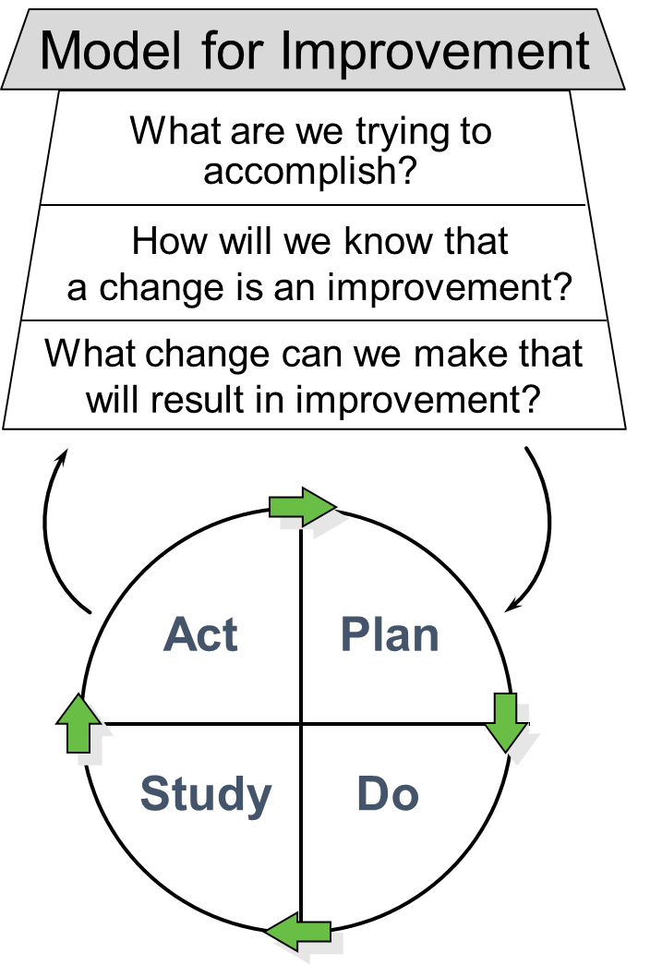
Quality Improvement and Quality Assurance
Quality improvement. From a performance improvement standpoint, consider a set of process and outcome measures that are aligned with the virtual care team’s goals. In addition to satisfaction surveys, clinical quality measures and UDS measures, consider the suggestions below.
- Percent of encounters that are telehealth visit vs. in-person visits
- Percent of visits that start and end on time – include reasons why visits did not start or end on time (e.g., provider running late, patient not ready on time, appointment time too short to cover issues, questions and concerns)
- ED visits, admissions and readmissions rates over time
- Clinical quality/UDS measures (e.g., vaccine and cancer screening rates, A1Cs, blood pressure control)
Quality assurance. Each person should have the same high-quality telehealth experience, regardless of several variables (e.g., workflows, devices, providers, support staff). Create a process to collect, collate and respond to questions/items related to telehealth. Below is a starter set of questions to assess the patient, provider and virtual care team experience.
BEST PRACTICE: Keep surveys short, focused and easy to complete. Sometimes just asking two simple questions is all that is needed “How was your visit? What could have gone better?”

Patient Telehealth Satisfaction Questions | Possible Responses
Overall, I am satisfied with my telehealth visit. | Strongly disagree (1)  Disagree (2)  Agree (3)  Strongly agree (4)
The process to sign on and begin the telehealth visit was easy.
The visit started on time.
The provider’s credentials were clearly displayed.
The provider and other team members introduced themselves.
I could see the provider clearly.
The provider listened carefully.
The provider explained things in a way that was easy to understand.
What could have gone better? | Free text box
Provider/Care Team Satisfaction Questions | Possible Responses
The telehealth visit went smoothly; I had the support I needed for any glitches. | Strongly disagree (1)  Disagree (2)  Agree (3)  Strongly agree (4)
The visit started on time.
The virtual care team performed well and completed all pre-visit tasks.
What could have gone better? | Free text box

HIPAA Privacy and Security: Virtual Care Team Considerations
HIPAA Privacy and Security are always at risk, but it is easier to control and mitigate that risk in the more controlled environment of the clinic. Below are several privacy and security considerations for the virtual care team.
HIPAA Privacy
Use a headset or earbuds. This is a recommendation for both the virtual care team and patients. An exam room provides a space for private conversations among patients, family, caregivers, providers, the care team and more; it is important to maintain a similar level of privacy during virtual communication. On both ends of the virtual communication, it is essential that 1) patients and providers can speak freely without risk of being overheard by someone who should not or does not need to hear the conversation and 2) the computer mic is not used when there are others near who can hear either or both sides of the conversation. Using a headset or earbuds can help alleviate this privacy issue.
Protect patient’s protected patient information.
- Use a privacy screen so others cannot read patients’ information
- Do not let family or friends use your work device
- Share the minimum necessary information for others involved in care of the patient

HIPAA Security
Adhering to the standards and implementation specifications components of the security risk analysis (SRA) is required by the HIPAA Security Rule. The checklist below provides some relevant guidance based on some of the required components of the SRA. Note that this is not legal advice nor is this checklist comprehensive by any means.
- Our designated Security Officer (required by HIPAA) has updated all relevant HIPAA standards and implementation specifications in our security risk analysis to include changes we have made with telehealth and other virtual services
- The Security Officer has provided training to all members of the virtual/hybrid team
- All devices (e.g., laptops, tablets, etc.) used by the virtual care team:
  - Are protected, using unique passwords for each user.
  - Have current and functioning antivirus software.
  - Terminate an electronic session after a predetermined time of inactivity.
  - Include ability to encrypt/decrypt electronic PHI (ePHI) when deemed appropriate.
  - Are included in the inventory of all devices that create, receive, maintain or transmit ePHI.
  - Can be remotely wiped and/or disabled (in the event of theft or loss of device(s)).
  - Are protected by a firewall whenever possible.
  - Have updated security software.
- We have a security awareness and training program that includes security concerns specific to the virtual care team
- Any telehealth platforms that we use are HIPAA-compliant, and we have signed business associate agreements (BAAs) for relevant persons or entities as described by the Office for Civil Rights

Resource:
Mobile Device Privacy and Security from HealthIT.gov: Provides specific guidance on how to protect and secure health information when using a mobile device.

Resources

FQHC-Specific Telehealth Resources:
- FQHCs & RHCs Acting as Distant Site Providers in Medicare. Center for Connected Health Policy. Succinct two-pager summarizing new and expanded flexibilities.
- Rural Health Clinics (RHCs) and Federally Qualified Health Centers (FQHCs): CMS Flexibilities to Fight COVID-19 See short section “Medicare Telehealth” that clarifies that for Medicare beneficiaries FQHCs can:
- Furnish distant site telehealth services during the PHE from any distant site location, including providers’ homes (during the time they are working for the FQHC) if it is within their scope of practice
- Use audio-only for select telehealth codes and services
- Provide telehealth to a patient’s home (originating site)
- Deliver any telehealth service that is included on the list of Medicare telehealth services under the Physician Fee Schedule (PFS), including those that are added on an interim basis during the PHE
- COVID-19 Frequently Asked Questions (FAQs) on Medicare Fee-for-Service (FFS) Billing Note section M “Rural Health Clinics (RHCs) and Federally Qualified Health Centers (FQHCs)”
- New and Expanded Flexibilities for Rural Health Clinics (RHCs) and Federally Qualified Health Centers (FQHCs) During the COVID-19 Public Health Emergency Excellent resource for billing telehealth for Medicare beneficiaries. CMS updated in Feb 2021 to include the 2021 reimbursement rate of $99.45 for telehealth services and $23.73 for G0071.
- Resources for Telehealth at Safety Net Settings from the University of California San Francisco – Center for Vulnerable Populations

NY Medicaid Telehealth Resources:
- Medicaid Update – Expansion of Telehealth. New York State Department of Health Update from 2019 with excellent telehealth information specific to New York Medicaid – see page 11 for FQHC-specific info about originating and distant sites. See Medicaid Update Special Edition (Resource #2) for Medicaid telehealth guidance specific to the COVID-19 State of Emergency.
- Medicaid Update Special Edition - Comprehensive Guidance Regarding Use of Telehealth including Telephonic Services During the COVID-19 State of Emergency Includes a nice table “Telephonic Reimbursement Overview” and also repeats information from other NY Medicaid telehealth resources. Many additional hyperlinked resources are included.
- FAQs Regarding Use of Telehealth including Telephonic Services During the COVID-19 State of Emergency
Excellent resource, and there is a section just for FQHCs. This is must-read.
- New York State Medicaid Telehealth Services During the Coronavirus Emergency Succinct two-page fact sheet.
- Official Compilation of Codes, Rules and Regulations of the State of New York. Title 14. Department of Mental Hygiene. Chapter XIII. Office of Mental Health. Part 596. Telemental Health Services Complete but short and succinct requirements when delivering telemental health services. If delivering telemental health services, it is strongly advised to be intimately familiar with the requirements outlined in this New York set of Codes, Rules and Regulations (CRR).
- New York State Telehealth Training Portal Excellent telehealth training offered by the Northeast Telehealth Resource Center. Must sign up for free account to access the trainings. Currently not offering CME/CEU.

General Telehealth Resources:
- CMS Telehealth Services Booklet. Centers for Medicare & Medicaid Services. Excellent resource with the details of telehealth service delivery for Medicare beneficiaries.
- CMS List of Telehealth Services. Centers for Medicare & Medicaid Services. Full list of telehealth services and codes – updated frequently during the COVID-19 pandemic but usually just updated annually.
- Physician Fee Schedule Look-Up Tool. Centers for Medicare & Medicaid Services. Use this tool to search pricing amounts for billing codes.
- Current State Laws & Reimbursement Policies. Center for Connected Health Policy. Telehealth policy changes, including comprehensive state-specific look-up tool with state Medicaid statutes and other information related to telehealth policy and allowances.
- Billing for Telehealth Encounters – An Introductory Guide on Fee for Service. Center for Connected Health Policy. March 2021. Excellent information about telehealth billing and reimbursement.
- American Medical Association Telehealth Implementation Playbook. American Medical Association. This is a fairly long document at 128 pages, but it is exceptionally complete and well done. Not all sections are relevant for the LTSS setting. However, it is worth scrolling through the document for the parts that are relevant such as Designing the Workflow and references to documentation.
- National Consortium of Telehealth Resource Centers – “Provides trusted consultation, resources & news at no cost to help you plan your experience.” Start here to find the HRSA-funded Telehealth Resource Center representing your state.
- Telehealth Services for Medicare Fee-for-Service Providers CMS fact sheet on telehealth – also applicable to FQHCs
- Health and Human Services Telehealth Homepage Excellent telehealth resources.

Appendices

Sample Team Compacts and Charter
Sample Virtual Care Team Goal(s):
Regardless of whether we are onsite at clinic, in our homes, at a patient’s home or elsewhere, all members of the virtual care team:
- Team-based health care services that are person-centered, equitable, safe, high quality and efficient.
- Continuous improvement.

Team Compact Example #1 from a health center - How We Work

We are committed to excellent, team-based, patient-centered care.
- I work with my team to provide excellent quality care.
- When a patient is with us, he or she is our patient.
- I provide for patients and find help for their needs in a friendly, safe environment
- I care for the whole person.
- If what I’m doing for a patient isn’t working, I try something new or ask for help.

We work with compassion.
- I remember that being a patient can be a confusing, lonely, or difficult experience.
- I treat patients and team members the way I would like to be treated.
- I respect other people’s time, space, emotions, and abilities.
- I offer help to patients and other team members and anticipate their needs.
- I approach difficult situations with curiosity and intent to help.

We are committed to excellence in communication.
- I greet patients and their family members with eye contact and friendly welcome.
- I convey friendliness, respect, and patience in person and on the phone.
- I use professional and respectful language.
- I explain things clearly to patients in a language they can understand.

We are committed to our team.
- I understand my own role and responsibilities and those of my teammates.
- I make our practice a place where people look forward to coming to work.
- I create a safe place for learners.
- I go above and beyond to help a patient or a team member.
- I work with our team to identify and solve problems
- I acknowledge the good work, good intent, and skill of my team members.

We increase our competence at our health center.
- I learn from my patients and team members of all disciplines.
- I am a role model for others.
- I share new ideas and respect those of others.
- I strive to continue to learn in my field and improve my skills.
- I act at the highest level of professionalism.
- I work to improve the way that our health center functions.
- I solicit, give, and receive feedback.

Team Compact Example #2 from a health Center

I promise to:
- Do my part in making our health center a place where we can look forward to coming to work and leave knowing we have done the best for our patients and ourselves
  - Take pride in ourselves, our work and our practice
  - Give my co-workers the benefit of the doubt and the space to be human
  - Approach an upsetting situation involving a co-worker with curiosity, not judgment
  - Do my part to help create an enjoyable work environment
- Celebrate our diversity – We believe our different backgrounds and trainings are our strength.
  - Create an environment where everyone participates, and everyone’s input is valued equally.
  - Respect and trust each other
  - Avoid language and actions that anyone could perceive as disrespectful
- Communicate in an open and honest manner and listen actively.
  - Address issues as they happen and be direct
  - Ask for, and thoughtfully consider, feedback from others; provide honest feedback
- Be my best and help others be their best
  - Keep my individual and our team focus on best serving our patients and commitment to our mission, vision and values
  - Keep commitments to co-workers, and when I can’t, to communicate that I can’t in a timely fashion
  - Be willing to step outside my usual role to do whatever needs to be done
  - Ask for help when I need it and accept help when offered
  - Never worry alone
- Learn
  - Identify and help solve problems, rather than just work around
  - Work constantly to improve our practice and learn from our patients and each other
  - Acknowledge, report, and learn from errors
  - Develop our collective skills and knowledge

Virtual Care Team Charter
Virtual Care Team members:

Purpose and Key Responsibilities

Vision

Values

Goals

Roles and Responsibilities

Mutual Expectations

Operating Procedures

Mini Z Burnout Survey

Copyright 2015 American Medical Association. All rights reserved.

Answer the following questions as truthfully as possible to determine your workplace stress levels and how they measure up against others in your field. There are two sections of questions in this survey about your experience with burnout and your practice environment. When you have completed the survey, return it to the person who requested that you complete it.
Mini Z burnout survey
Name: |  | Role:
Team/department: |  | Date of survey:
For questions 1-10, please choose the answer that best describes your experience with burnout. Please circle your answers.
- Overall, I am satisfied with my current job: | 1 Strongly disagree |  | 2 Disagree | 3 Neutral | 4 Agree | 5 Strongly Agree
- I feel a great deal of stress because of my job: | 1 Strongly disagree |  | 2 Disagree | 3 Neutral | 4 Agree | 5 Strongly Agree

- Using your own definition of “burnout,” please circle one of the answers below:

- I enjoy my work. I have no symptoms of burnout.
- I am under stress, and don’t always have as much energy as I did, but I don’t feel burned out.
- I am definitely burning out and have one or more symptoms of burnout, e.g., emotional exhaustion.
- The symptoms of burnout that I am experiencing won’t go away. I think about work frustrations a lot.
- I feel completely burned out. I am at the point where I may need to seek help.

- My control over my workload is: | 1  Poor | 2  Marginal |  | 3  Satisfactory |  |  | 4  Good |  | 5  Optimal
- Sufficiency of time for documentation is: | 1  Poor | 2  Marginal |  | 3  Satisfactory |  |  | 4  Good |  | 5  Optimal
- Which number best describes the atmosphere in your primary work area? | 1  Calm | 2 |  | 3  Busy, but reasonable |  |  | 4 |  | 5  Hectic, chaotic
- My professional values are well aligned with those of my department leaders: | 1 Strongly disagree |  | 2 Disagree |  | 3 Neither agree nor disagree | 4 Agree |  | 5 Strongly Agree
- The degree to which my care team works efficiently together is: | 1  Poor | 2  Marginal |  | 3  Satisfactory |  |  | 4  Good |  | 5  Optimal

- The amount of time I spend on the electronic health record (EHR) at home is: | 1  Excessive | 2  Moderately high | 3  Satisfactory | 4  Modest | 5  Minimal/none
- My proficiency with EHR use is: | 1  Poor | 2  Marginal | 3  Satisfactory | 4  Good | 5  Optimal

- Tell us more about your stresses and what we can do to minimize them (optional):

Your clinical practice
Answer the following questions as truthfully as possible to determine your workplace stress levels and how they measure up against others in your field.
For the following, please tell us about yourself and your practice. Please fill in the blanks.
Are you: __ MD/DO __ NP __ PA __ Other (specify):____________________
Specialty: | Practice name:
City of practice: | State of practice:
Practice size (# physician FTEs): | Are you: __ Employed __ Owner
Practice type: __ VA __ Non-VA | Practice specialty:
EHR vendor (optional):
For the following, please choose the answer that best describes you.
Where do you spend the majority of your clinical time? __ Inpatient __ Outpatient
Please tell us the number of years in your current role: ____________
Gender (optional): __ Female __ Male
Race (optional): __ Black or African American __ Asian __ Native American __ Native Hawaiian or Other Pacific Islander __ White
Ethnicity (optional): __ Latino/Hispanic __ Not Latino/Hispanic __ Prefer not to answer

*Questions drawn mainly from the Physician Worklife Study, MEMO study, and Healthy Workplace Study. The Mini Z was developed by Dr. Mark Linzer and team at Hennepin County Medical Center, Minneapolis. For more information, please contact mark.linzer@hcmed.org.

Thank you for taking the Mini Z survey.

The Academic Innovations Collaborative Teamness Survey
The Teamness Survey was developed as part of the Academic Innovations Collaborative (AIC) led by the Harvard Medical School Center for Primary Care. Comagine Health technical assistance and program planning from 2012 – 2016.
The survey items have been primarily drawn from a number of well-validated survey instruments and have already been used in two surveys by the AIC Evaluation Team led by Sara Singer, PhD of the Harvard T.H. Chan School of Public Health. The survey is based on an extensive review of items from teamwork surveys used in more than 40 published studies. From these, the evaluation team developed a conceptual model that included the important elements described in these studies but that also felt most relevant to the overall work of AIC. Finally, the Evaluation Team took these items from existing surveys, and revised them so they flowed together and created an initial version. They did cognitive testing, similar to work done in the PROMISES Project, but with more people, and then field-tested, which was found to have excellent psychometric results/properties. They made minor modifications with the second version that worked even better. The questions below are based on that version. The entire AIC team including our patient advisor provided additional feedback that was incorporated into the final set of questions.
The Harvard Medical School Center for Primary Care has granted permission to share the Teamness Survey as long as proper attribution is given. When using this survey, make sure you include “Copyrighted by the Harvard Medical School Center for Primary Care – used with permission.”
Rate your level of agreement with the following statements on a 1-5 scale where 1 is strongly agree and 5 is strongly disagree.
- There is a real desire among team members to work collaboratively.

- My team functions very well together to deliver care.

- Roles are clearly defined on my team.

- When team members disagree, all points of view are considered before deciding on a solution.

- My team has been effective in its quality improvement work (accomplishing improvement objectives through PDSA cycles, etc.).

- Working on our team keeps members of my team enthusiastic and interested in their jobs.

- Patients and family members are full members of our healthcare team.

What, if anything, can we do to improve teamwork?

20 Things to Know about Telehealth
Telehealth or telemedicine are both used to describe any health care service that uses technology for visits with your provider or care team that are not in person. Other terms are digital medicine, virtual visits, video visits, e-health or m-health (for “mobile”). Here are twenty things patients and family members have identified that are important to know about telehealth.
- Telehealth in place of in-person visits is a good option during the COVID-19 pandemic to keep people safe from COVID-19 infection.
- A telehealth visit can save you time because you do not have to go to the clinic or wait in the waiting room.
- Telehealth visits usually cost the same as an in-person visit with the same copays and deductibles. The difference could depend on your insurance. Do not hesitate to ask what you will have to pay out of pocket and when it is due.
- Ask in advance how to pay your copay in case you can pay on the day of your visit rather than waiting for them to mail you a bill.
- If you have Medicare, your provider is required to get your consent before starting a telehealth visit.
- When you schedule a telehealth visit, if you are unsure you need to do ask if someone from the clinic can help get you set up for your visit. Some clinics will even do a test with you before your visit.
- If your provider allows it, you might be able to have other people like a family member or care giver join your virtual visit.
- You will need a device with audio, such as a speaker and mic and video, such as a webcam or a camera that is embedded in a computer, smartphone or tablet for a telehealth visit.
- You will need a way to connect with your health care team and may need an internet connection, data plan, email or something else.
- Make sure you have a quiet, private place to have your telehealth visit.
- If you are not in a private area and are in place where others might be able to listen in, protect your privacy and use a headset or earbuds.
- Do not multitask during your telehealth visit. Treat it just like an in-person visit.
- Make sure your provider has a back-up plan, like calling you on your phone, if the telehealth visit does not work.
- Have your list of questions written down so you do not forget what to ask. It is easy to get distracted when you are trying to figure out how to do your telehealth visit.
- Get all your medications and have them with you for your telehealth visit.
- When your visit starts, if you cannot tell who a person on the health care team is at any time, ask them who they are. They should have identification badges or a sign behind them saying who they are. They often forget so you might have to remind them to tell you who they are.
- Ask how long your visit is if you are unsure. You can do this when you schedule or once you connect for your telehealth visit.
- Once your video is connected, take a look at where you are in the frame. Can the provider see your entire face? If you cannot tell, ask your provider or care team if they can see you okay.
- During the visit, if ANYTHING is not working for you for any reason, let the provider or care team know – no matter if it is because the video is glitchy, you cannot hear them, you do not feel comfortable or any other reason.
- At the end of the visit, ask your provider or care team for a copy of your treatment plan or summary, including when they want to see you next.
BONUS: Check out this great six-minute video: What to Expect from a Telehealth Visit https://www.youtube.com/watch?v=Olgs6mMXt6U&feature=youtu.be

My Telehealth Checklist

Before the telehealth visit
- I have a device with a camera, speaker and microphone. A device might be a computer, tablet, laptop or a smartphone.
- I have a quiet and private place with good lighting for my telehealth visit.
- I have internet (or other connection such as my phone data plan) for a telehealth visit. Being able to stream movies means my internet should be good enough for telehealth.
- My provider’s office has confirmed that a telehealth visit is okay for my visit reason or concern; I do not need an in-person visit.
- I have asked my provider’s office to do a test connection with me to make sure everything works okay. Not always needed but can be helpful.
- My provider’s office knows if I need translation or other support during my telehealth visit, including having a family member or caregiver join the telehealth visit.
- I have submitted any forms or information – either paper or online – that my provider’s office needs me to fill out or provide.
- I have my list of questions ready.
- I have all my medication bottles nearby for when they ask me what I am taking.
- I have closed all extra windows, tabs and applications on my device and asked everyone else in my house not to use the internet during my telehealth visit.
- My device is either plugged in or fully charged.
- I know how I will receive the link to join my telehealth visit, and I know how to find it. The link may be sent by email, text, or online portal or some other way.
- They gave me instructions on how to start or join the telehealth visit.

During the telehealth visit:
While I will not be able to check this list during the visit, these are things to think about.
- I have my questions, concerns and issues organized and listed by importance (if possible). (If it is an option, I have sent my list to my provider BEFORE the meeting.)
- My face is centered in the screen. The camera is aimed at me, not at the ceiling or just showing my forehead or chin.
- The provider or care team has clarified how much time we have.
- I can see and hear the provider and the care team members. If not, I need to let them know.
- They gave me back-up plan in case we have technical problems. I have a phone number to call.
- I know what the treatment plan is and have asked the provider to send me a copy of the treatment plan for future reference.
- If tests or referrals to specialists are ordered, I know why I am getting them and where I need to go.
- My provider told me when I need schedule my next or follow-up visit.
- I have a number to call with any follow-up questions.
- I have a number to call if I have problems after hours.
- My provider’s office has told me what my copay or fees are for the telehealth visit and how to pay.

Lencioni, P.M. (2002). The five dysfunctions of a team. Jossey-Bass.
Ibid.
Arndt B et al. Tethered to the EHR: Primary Care Physician Workload Assignment Using EHR Event Log Data and Time-Motion Observations. Ann Fam Med 2017;15:419-426.
Chiapetta M. The Technostress: definition, symptoms and risk prevention. Senses Sci 2017:4(1)358-361.
Note that there are growing concerns about fraud and abuse with telehealth. Do the best you can to confirm the identity of the patient and make sure to document how the patient was identified in the medical record.
Medicaid Update – Expansion of Telehealth. New York State Department of Health. https://www.health.ny.gov/health_care/medicaid/program/update/2019/feb19_mu_speced.pdf
FAQs Regarding Use of Telehealth including Telephonic Services During the COVID-19 State of Emergency. https://www.health.ny.gov/health_care/medicaid/covid19/docs/faqs.pdf
Business Associates. U.S. Department of Health & Human Services – Office for Civil Rights. Accessed Jan 4, 2021. https://www.hhs.gov/hipaa/for-professionals/privacy/guidance/business-associates/index.html
The PROMISES (Proactive Reduction of Outpatient Malpractice: Improving Safety, Efficiency, and Satisfaction) Project was funded by the Agency for Healthcare Research and Quality (AHRQ) and led by the Massachusetts Department of Public Health with several partners to teach improvement skills to small and medium-sized primary care practices across Massachusetts. https://psnet.ahrq.gov/issue/promises-project

