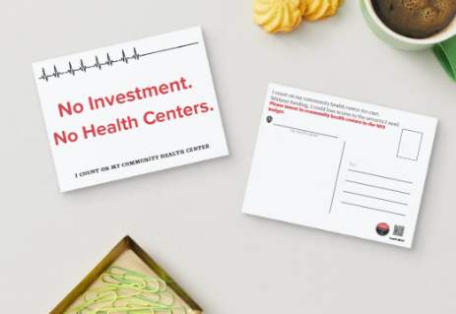
How to Fill Out Your Postcard
Tell your legislators why community health centers matter to you
Your voice matters. This postcard will be sent to your state assembly members and senators to help support community health centers like this one, ensuring you can get the care you need.
Step 1: Write a Short Message
Add a brief note on the back of the postcard. One sentence is enough. For example:
- “This health center is important to me because…”
- “Without this health center, I would not be able to get the care I need.”
- “Please invest in community health centers so patients like me can keep our care.”
Feel free to use your own words.
Step 2: Add Your Information
Please print clearly:
- Your first name
- Your ZIP code
(You do not need to include your full address.)
Step 3: Choose How Your Postcard Is Sent
You may choose one of the options below:
Option A: Health Center Sends It for You
- Leave the postcard with staff once it is completed.
- The health center will deliver it to your state legislator on your behalf.
Option B: You Send It Yourself
- Take the postcard with you.
- Mail it to your state legislator using the address and stamp provided
Both options ensure your message is heard.
Thank you for taking a moment to speak up. By sharing your experience, you are helping to support health centers like this one to continue serving people like you

